Installation & CI/CD tools Deployment for Openshift

November, 2019

Version 1.0

Document Release Note

Document Classification: TCS NextGen Internal

Project: TCS NextGen COE

Document details

|  |  |  |  |
| --- | --- | --- | --- |
| Name | Version no. | Author | Description |
| Installation & CI/CD tools Deployment for Openshift | Version 1.0 | Raghuveer Muthoju | This document describes procedure for Openshift installation and CI/CD tool Deployments |

|  |  |
| --- | --- |
| Reviewed by: Lavanya Sirigudi | Date: |
|  |  |
| Approved by: Surekha Sakinela | Date: |

Contents

1. What is Openshift
2. Reference Architecture
3. Openshift Installation Procedure
4. GitLab Deployment on Openshift
5. Nexus Deployment on Openshift
6. SonarQube Deployment on Openshift
7. Usage of OCP CLI Commands
8. What is Openshift

OpenShift is Red Hat's Platform-as-a-Service (PaaS) that allows developers to quickly develop, host, and scale applications in a cloud environment.

Openshift makes use of the Kubernetes upstream project to provide a secure, robust, and extendable manner for orchestrating applications. Openshift works to further the access management and build/deploy services that are provided in the upstream Kubernetes project. Development teams are empowered to own and maintain their applications through production environments, while operations teams can provide the guide rails for developers to have that application ownership in a multi-tenant environment.

2. Reference Architecture

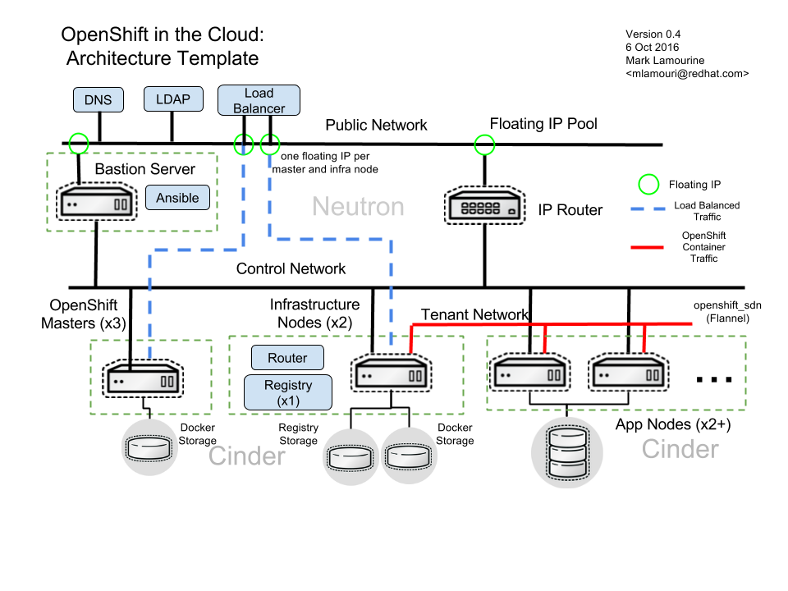

3. Openshift Installation Procedure

Openshift Installation procedure depends on a number of services and settings that must be in place before proceeding.

Openshift Installation procedure assumes:

* Red Hat OpenStack Platform 10 or later
* Openstack Platform(OSP) Port security controls must be enabled in neutron service
* RHOSP user account and credentials
* A Red Hat Enterprise Linux cloud image pre-loaded in glance (Nokia-customized Red Hat images were used. With these images, there were package mismatch issues between already enabled repos and ocp3.6. It is suggested to use images from Redhat site)
* A Red Hat Enterprise Linux update subscription credentials (user/password or Satellite server)
* An SSH keypair pre-loaded in nova
* A publicly available neutron network for inbound access
* A pool of floating IP addresses to provide inbound access
* Local DNS server to provide hostname resolution for local cluster
* An existing LDAP or Active Directory service for user identification and authentication
* Below link provides step by step installation of Openshift origin

<https://remote-lab.net/aio-okd-311-lets-encrypt>

4. Jenkins Deployment on Openshift

**Pre-requisites:**

OpenShift is UP and running.

Jenkins v2.130 docker image is in place to pull from OpenShift image registry.

Jenkins v2.130 openshift based docker image with following plugins:

* SSH Slaves: v1.26
* Email Extension: v2.62
* Role-based Authorization Strategy: v2.8.1
* Keycloak Authentication Plugin: v2.2.0
* GitLab Plugin: v1.5.9
* Discard Old Build plugin: v1.05
* Persistent Build Queue Plugin: v0.1.1
* Robot Framework: v1.6.4
* Workspace Cleanup Plugin: v0.34
* Xvfb plugin: v1.1.3
* Authorize Project: v1.3.0

**Creating Jenkins v2.130 Docker image**

We can either create a new Jenkins v2.130 image using “Dockerfile” or Push an existing Jenkins v2.130 image to docker registry.

To create a Jenkins v2.130 image

1. Login into any master node VM of OpenShift.
2. Check if docker service is UP and running.

# sudo systemctl status docker

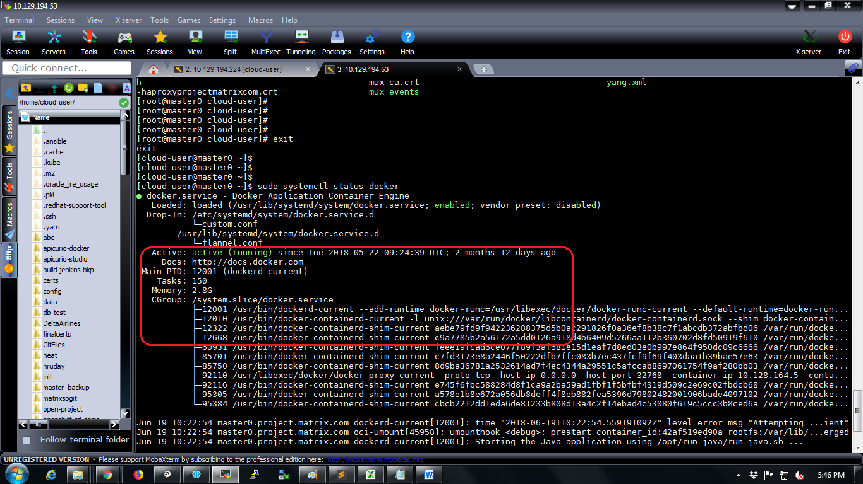

1. Create a directory in the VM.

# mkdir jenkins-ocp-image-files

# cd jenkins-ocp-image-files

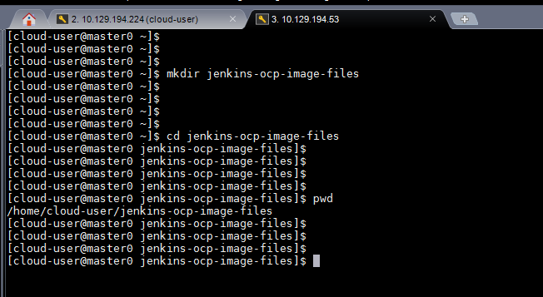

1. Copy attached file below to the above created directory in VM.

[Use “scp” ot “ftp” to copy the file if using linux or use “winscp” if using windows.]



Extract the file

# sudo unzip jenkins2130-docker-img-setup-files.zip

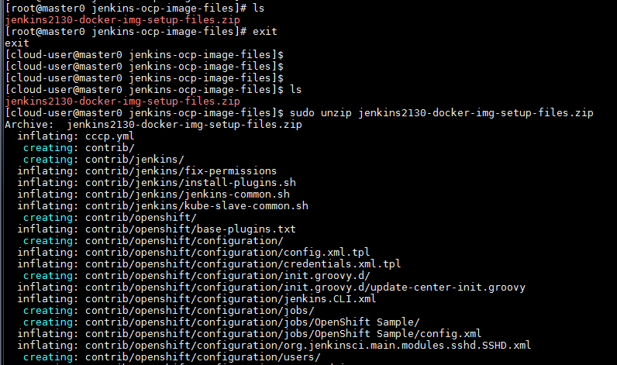

Set permissions to the directory

# cd ..

# sudo chmod –R 777 jenkins-ocp-image-files/

# cd jenkins-ocp-image-files/

# ll

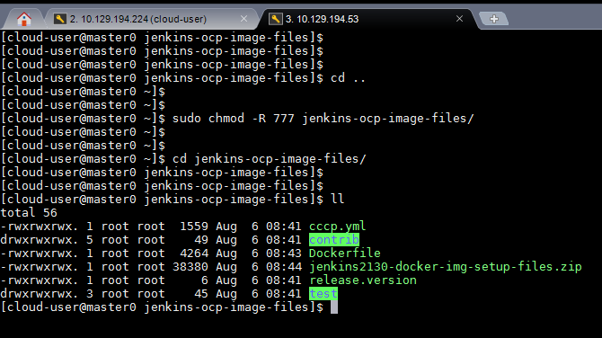

1. Run the docker file to create Jenkins v2.130 image.

# sudo docker build -t jenkins:2.130 . [Make sure not to ignore the (dot) at the end of the command]

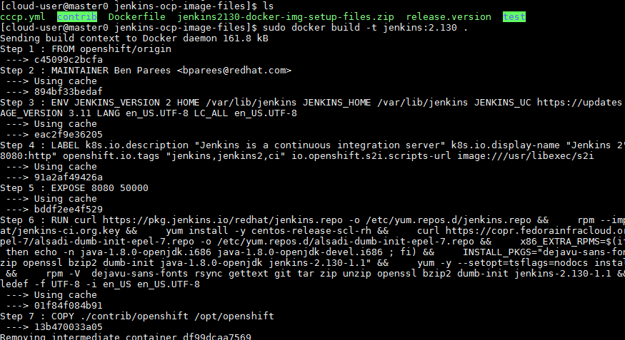

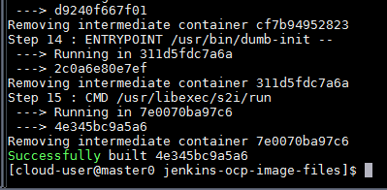

The above screenshot shows that jenkins v2.130 docker image is successfully created.

Verify docker image creation using following command.

# sudo docker images | grep jenkins

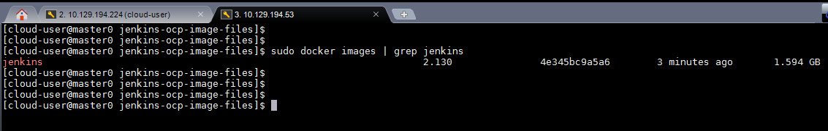

1. Get the token to login into docker registry

# oc login -u test

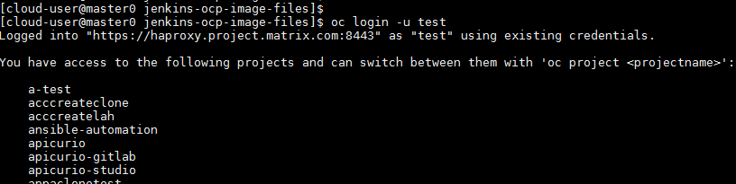

# oc whoami -t

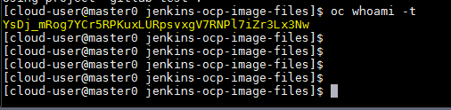

The highlighted part in the above screenshot is the token used to login into docker registry.

1. Login into docker registry

# sudo docker login -u test -p <use token generated in above step> docker-registry.default.svc.cluster.local:5000

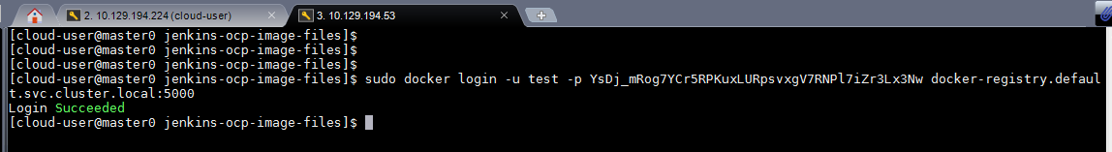

Now tag the image before pushing it to docker registry

# sudo docker tag jenkins:2.130 docker-registry.default.svc:5000/openshift/jenkinsstaging:2.130

[anyname can be given instead of “jenkinsstaging”]

Then push the image to docker registry

# sudo docker push docker-registry.default.svc:5000/openshift/jenkinsstaging:2.130

**Creating Build Jenkins in OCP.**

Jenkins v2.130 can be launched in OCP using a template.

Login into OpenShift console.

Click on Create Project button.

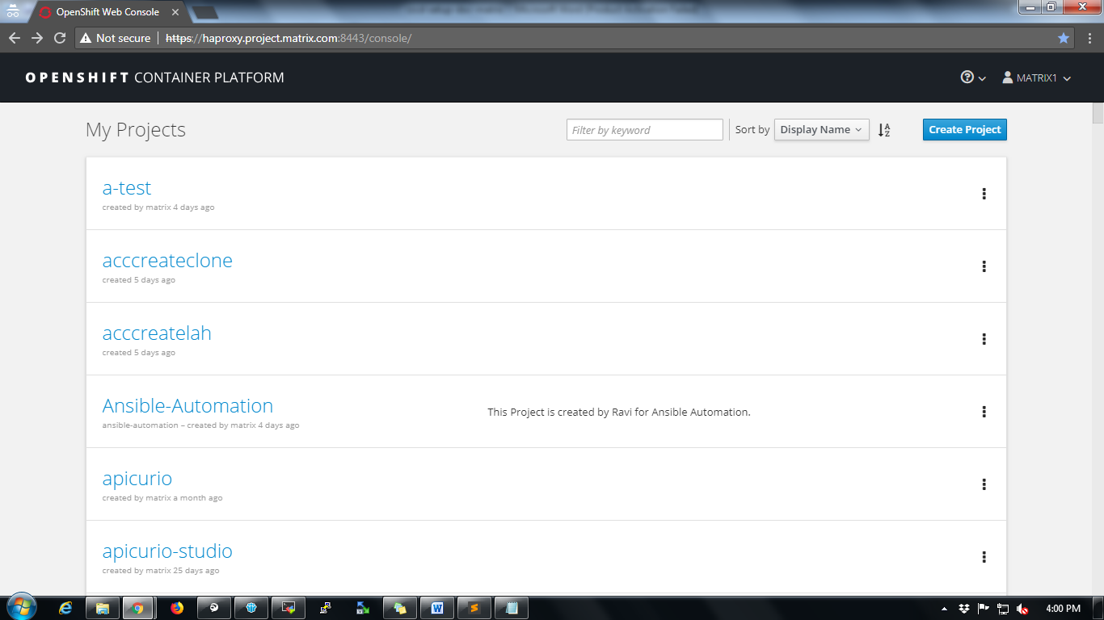

Fill up project details and click on Create button.

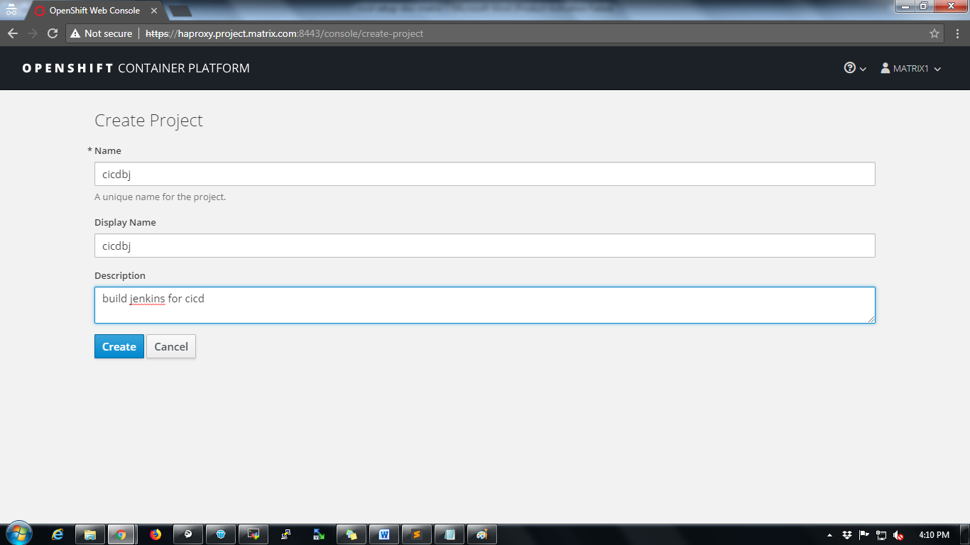Next add the Jenkins v2.130 template json file to your project.

Click on “Import YAML / JSON” tab and paste the content in attached template file on to the clipboard. Click on Create button.



Note:

Before importing the template refer the image of Jenkins from the OpenShift registry.

Open the attached template file and search for the following line

"docker-registry.default.svc:5000/openshift/jenkins2130u@sha256:617d4936cb71fa5e9274e6d89ee2c893bcbaaea5eb114fbafd4ba766c6b1f94c"

Replace this line with following line

“docker-registry.default.svc:5000/openshift/jenkinsstaging”

Also search for following content inside template

{

"description": "Name of the ImageStreamTag to be used for the Jenkins image.",

"displayName": "Jenkins ImageStreamTag",

"name": "JENKINS_IMAGE_STREAM_TAG",

"value": "jenkins2130u:2.130"

},

Replace "value": "jenkins2130u:2.130" with “value”: “jenkinsstaging:2.130”

After replacing the line import the template.

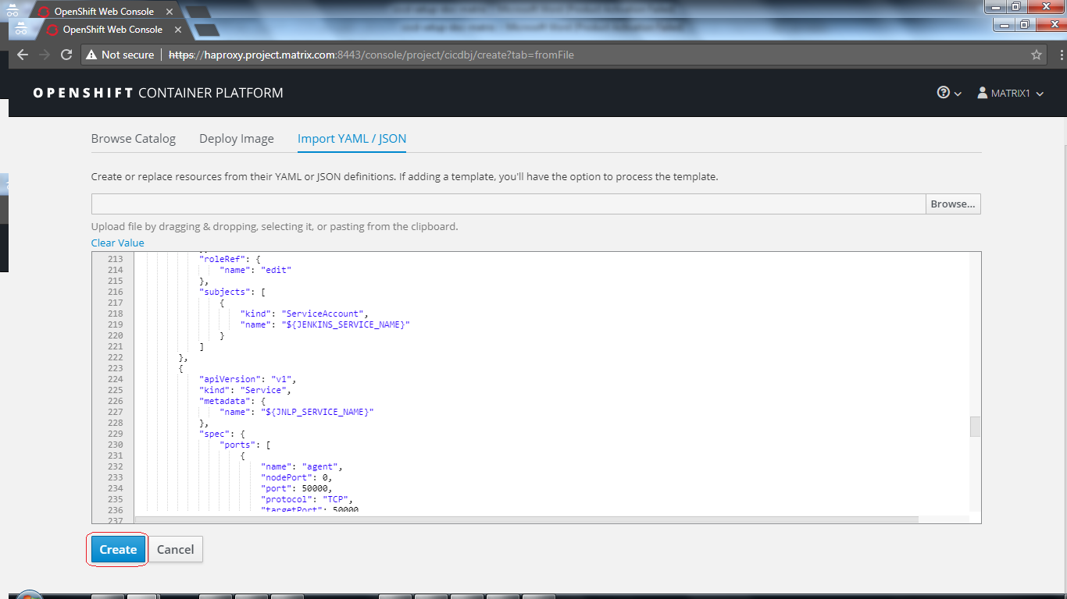

A prompt “Add Template” will be displayed on screen then click on Continue button.

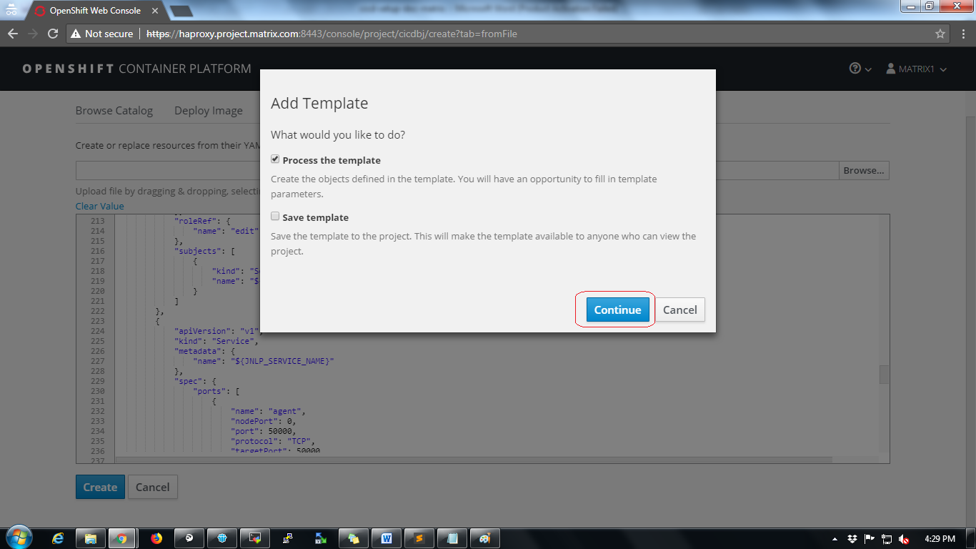

Configure Jenkins container parameters as follows.

Change “Jenkins Service Name” field to any name like eg: cicdbuild

Set “Memory Limit” field eg: 2048Mi (for Jenkins container with 2GB of RAM)

Set “Volume Capacity” field eg: 10Gi (for Jenkins container with 10GB of Disk Space)

Refer below screenshot for a sample parameter configuration.

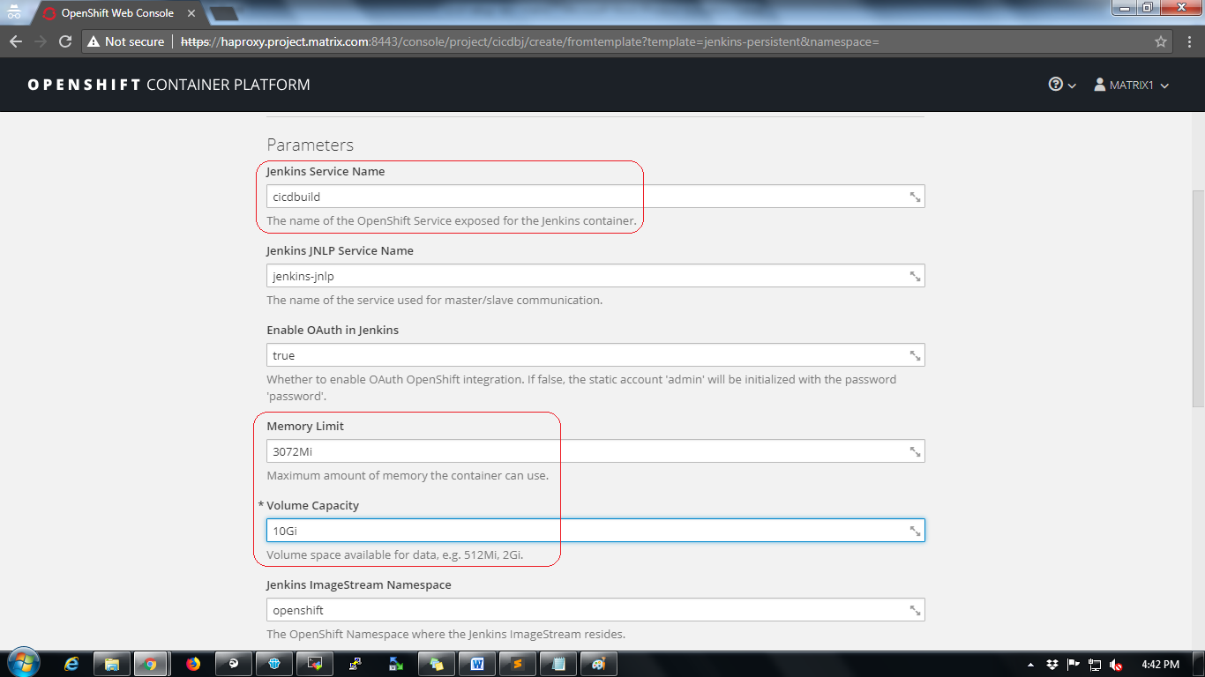

Click on Create button at the bottom of the page

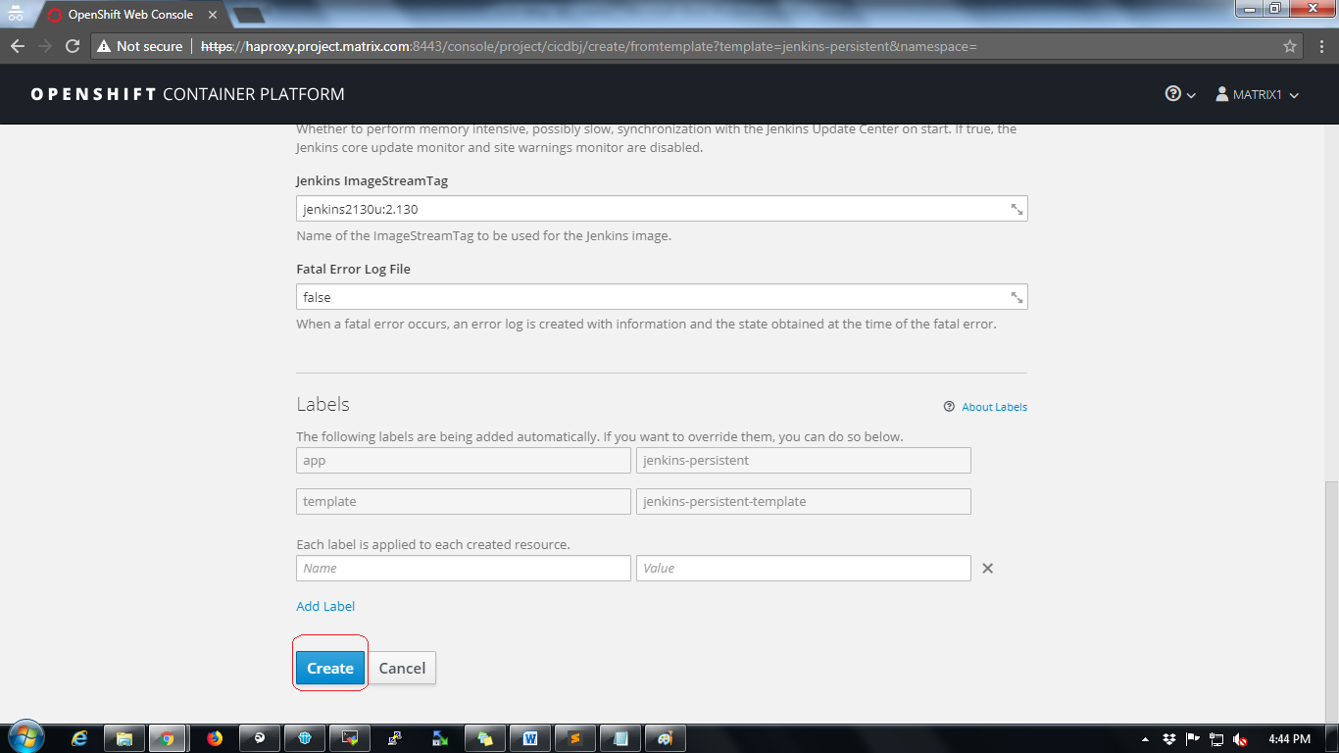

A popup will be displayed to grant permissions to the project then click on “Create Anyway” button.

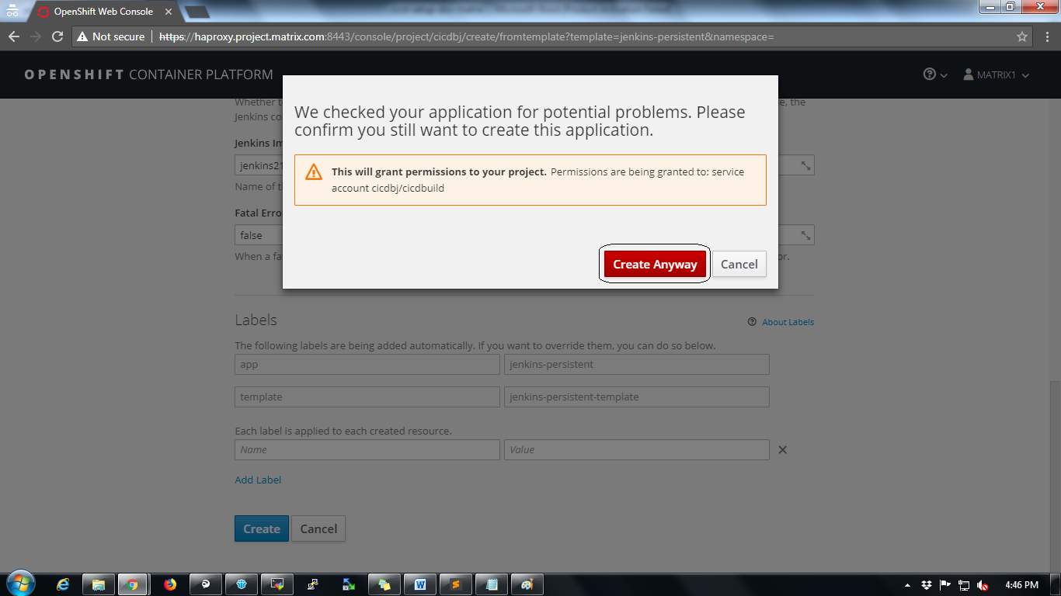

The next page will show status that “Application created”.

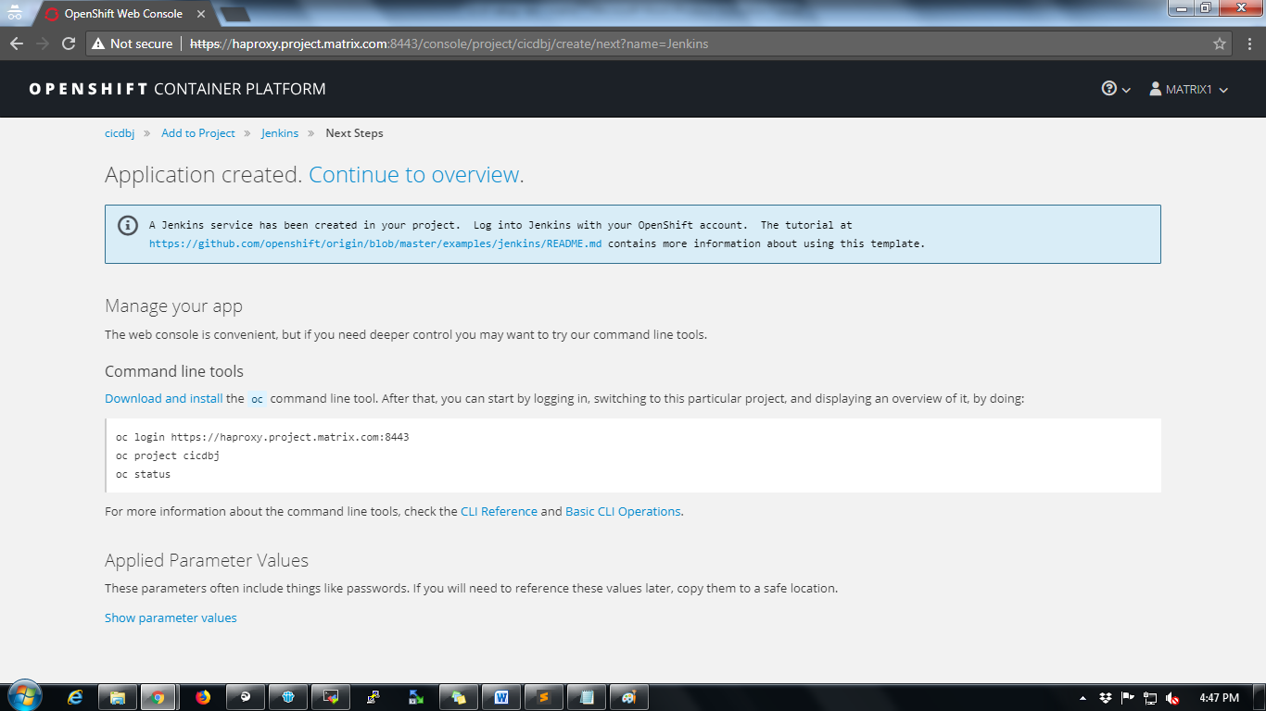

Wait for a while till the status shows “Completed” as shown below

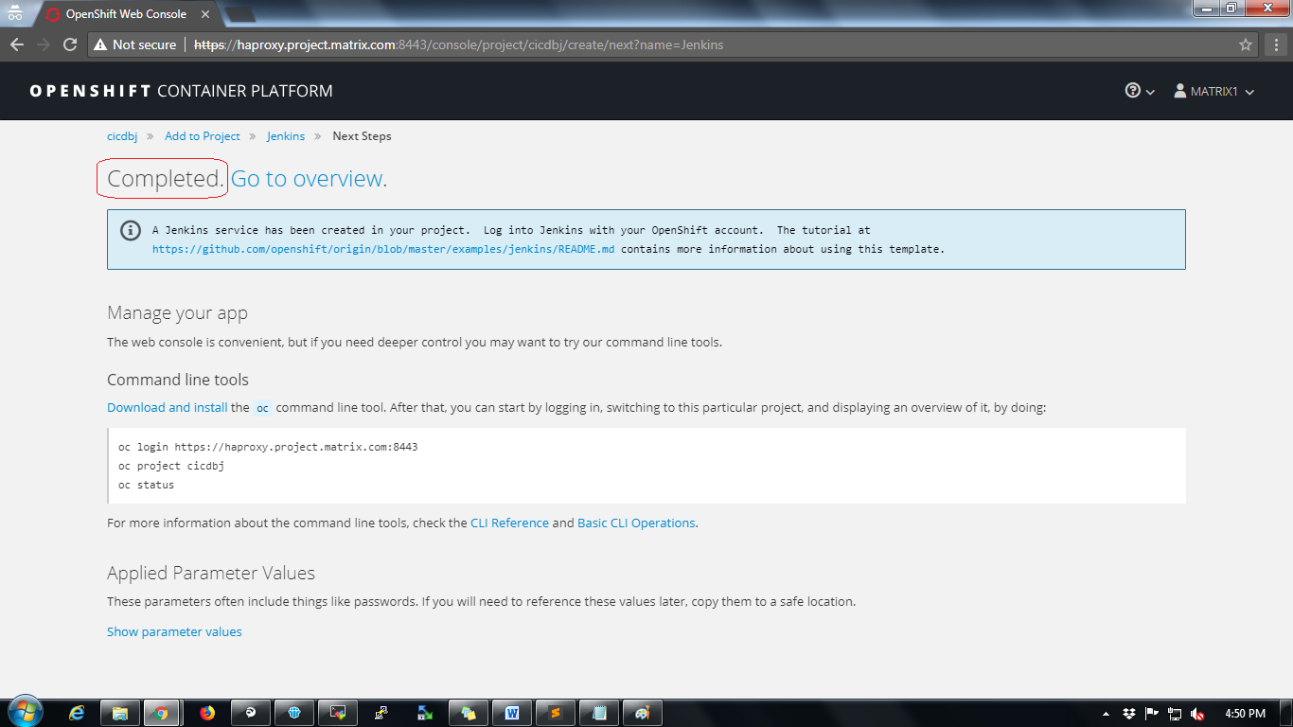

Click on “Go to overview” tab to verify the project home.

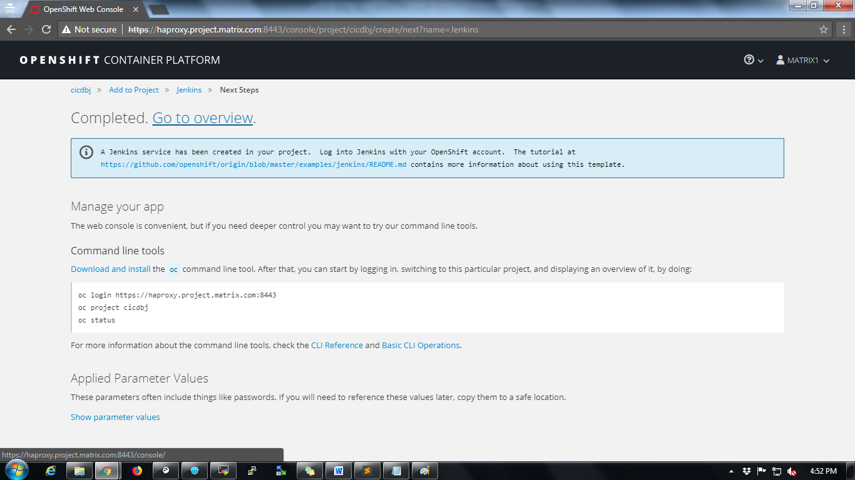

**Access Jenkins URL**

To access Jenkins follow below steps

Click on Applications🡪Routes

All routes accessible to Jenkins will be displayed.

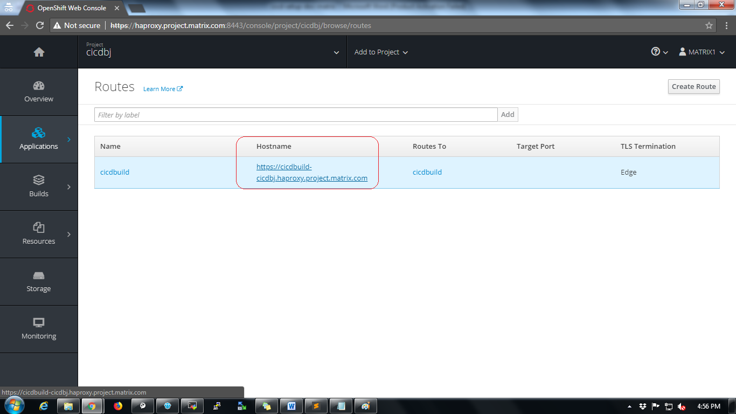

Now copy the hostname as highlighted in below screenshot and add to local computer’s hosts file to access using browser. While adding the hostname in hosts file make sure it is mapped to proper haproxy VM IP address of OCP. Follow same procedure for other tool deployments.

Refer below screenshot

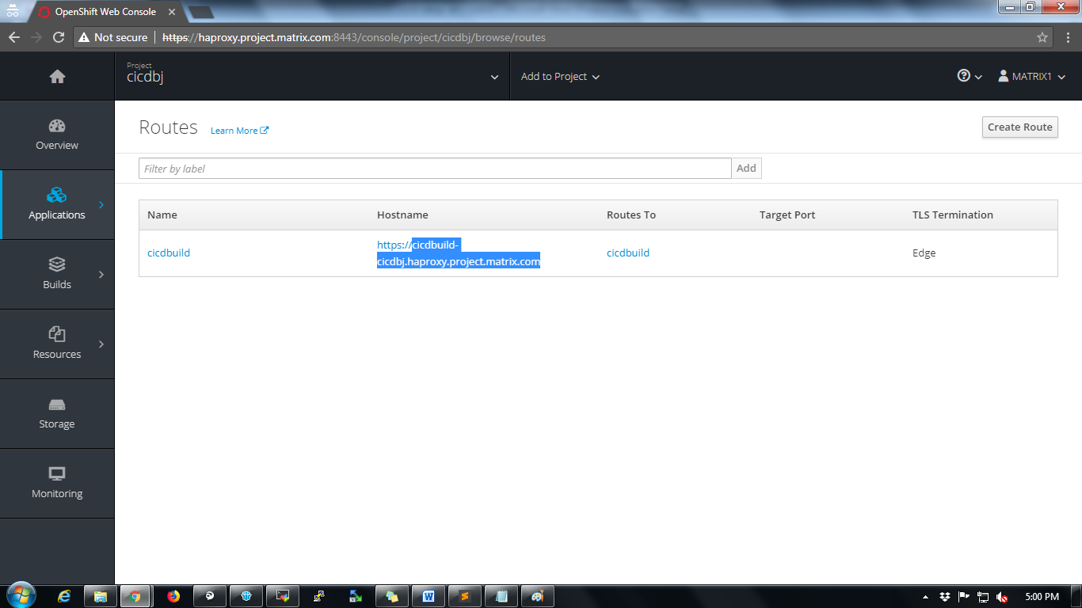

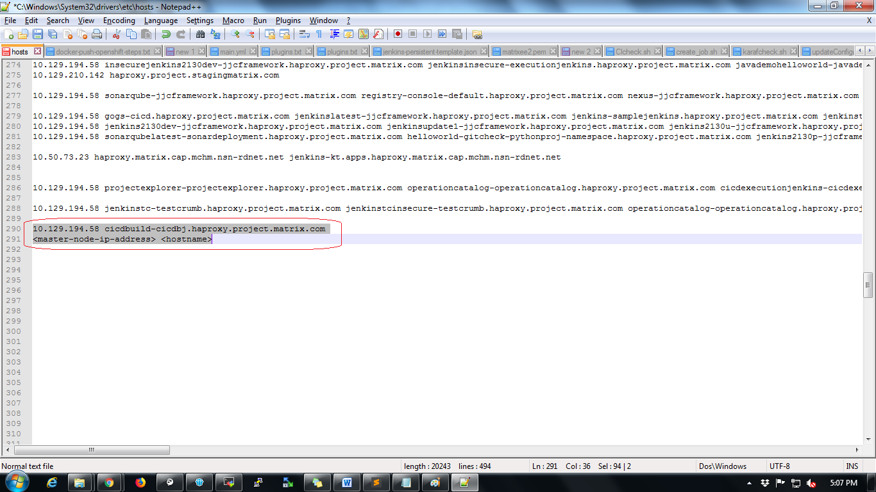

Now try to access the application using the url and login with openshift credentials. Click on “Log in with OpenShift” button.



Click on "openldap_auth" option in next page

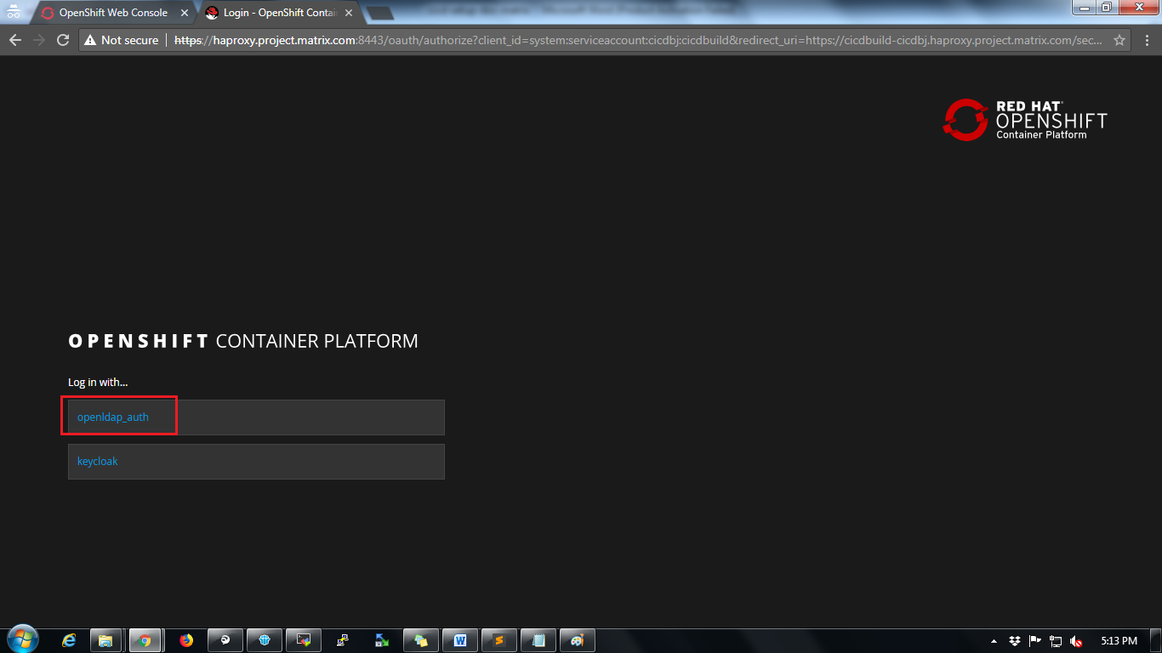

Provide credentials and click on “Log In” button in next page to login into Jenkins.

Username: matrix

Password: matrix

In next page “Authorize Access” click on “Allow selected permissions” button

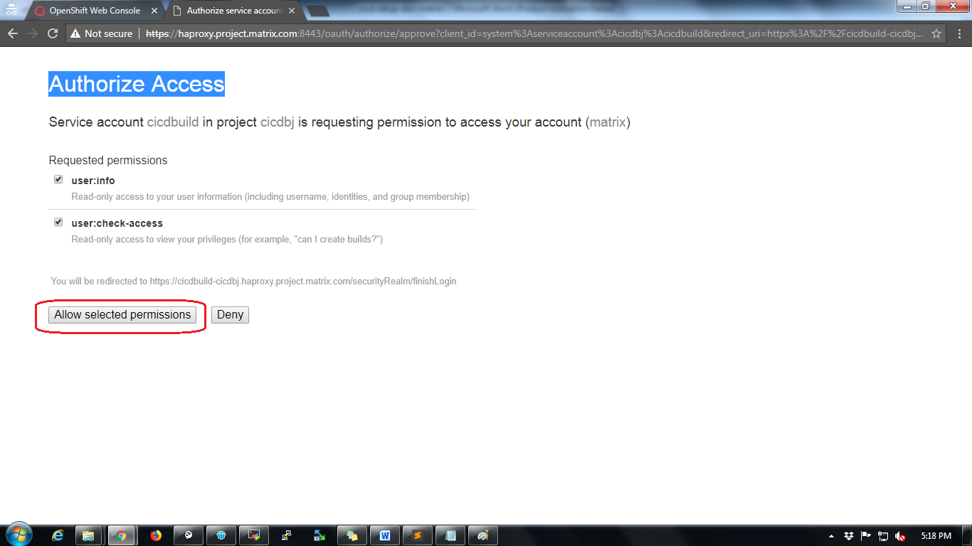

Verify the Jenkins version at the bottom of the page.

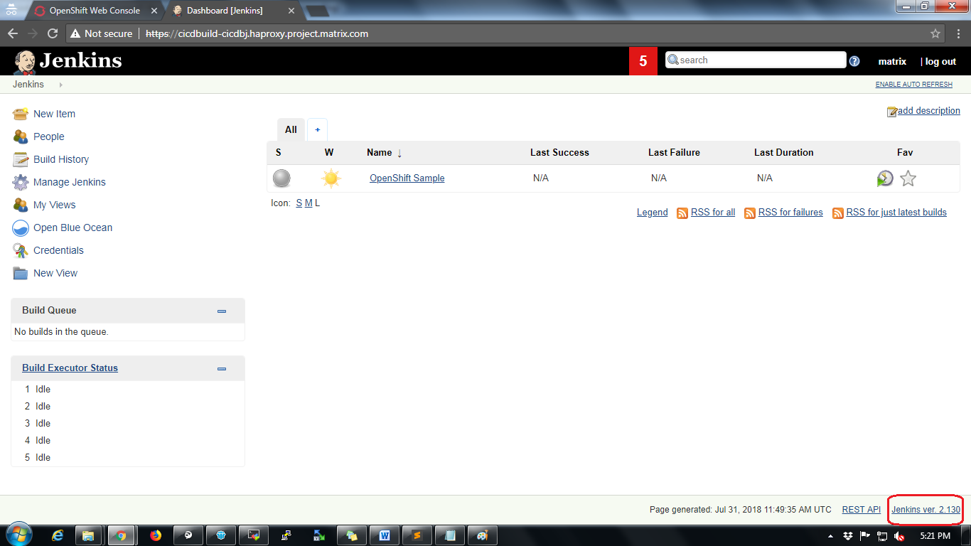

5. Gitlab Deployment on Openshift

Follow below steps for Gitlab deployment on Openshift:

* Open openshift UI, create new project, Click on "add to project " and go to “Deploy Image", select “Image Name” and give the following image “docker.io/gitlab/gitlab-ce” and click on search.



* If Gitlab-ce pod goes to crashloop back off error due to permission denied, Execute the next step commands.

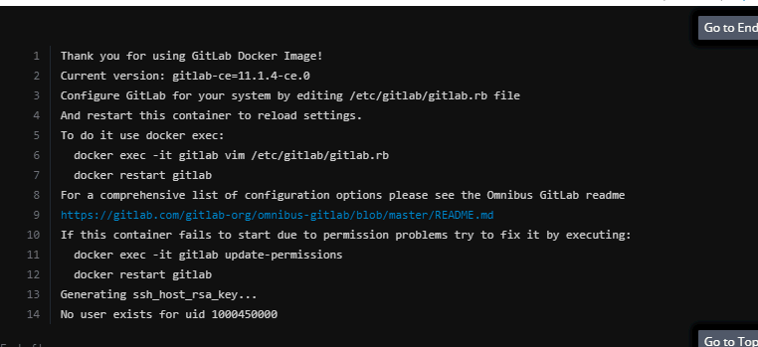

Login to openshift master node and add root permissions to the gitlab-ce deployment

oc create serviceaccount useroot -n <project-name>

oc adm policy add-scc-to-user anyuid -z useroot -n <project-name>

oc get dc -n <project-name>

oc patch dc/<gitlab-ce deployment name> --patch '{"spec":{"template":{"spec":{"serviceAccountName": "useroot"}}}}' -n <project-name>

Persistent Volume Creation:

* In openshift UI open the created project and go to “deplyoments” open the deplyoment click on “actions>edit” and change the deployment strategy to “recreate”, a pop-up appears click on “yes” and click on “save”.

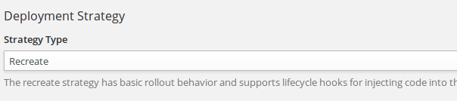



* Now go to ”Storage”, Click on “create” ,

Create 3 volumes with 20 GB storage each with the following details as given in the below image

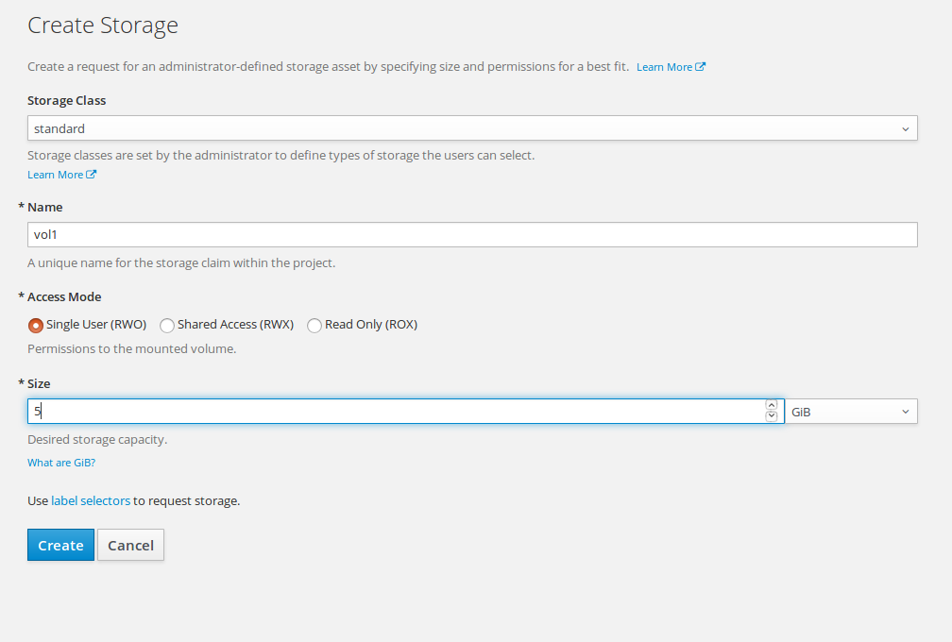

Login to master node and run the following commands:

-->oc get pods

-->oc describe pod <pod-name>

-->oc get dc

-->oc volume dc/<deployment-name> --add --overwrite --name=<volume-name> --type=persistentVolumeClaim --claim-name=<created vol-name>

Overwrite the volumes for all 3 volumes.

**Note:** Get deployment name and volume name from the first two commands

**Example:**

oc volume dc/gitlab-ce --add --overwrite --name=gitlab-ce-1 --type=persistentVolumeClaim --claim-name=vol1

**Route Creation:**

**Openshift UI:**

Go to Openshift UI, open the project go to "Applications>Routes" and click on "create route", Provide the name, and select target port to 80 – 80.

Once route for gitlab service has been created, add the below environment variable for that deployment(gitlab).  
Process: Go to deployments select gitlab deployment, in actions select "edit" and add the below variable and value in the Environment tab.  
  
Variable ---> GITLAB_OMNIBUS_CONFIG   
Value ---> hostname='<gitlab-route>';external_url "http://#{hostname}/" unless hostname.to_s == '';

Once the pod is up and running, set the gitlab root password by accessing the GitLab route.

**Settings in Gitlab to allow Outbound requests:**

Below setting to be made in Gitlab with admin credentials:

* + 1. Click on Admin area icon as below



1. Click on Settings icon on left side panel, search for Outbound requests option then click on expand
2. Enable Allow requests to the local network from hooks and services as below and click Save changes.



**Settings in Gitlab to allow Developer to push to master:**

Login with Admin and navigate to settings

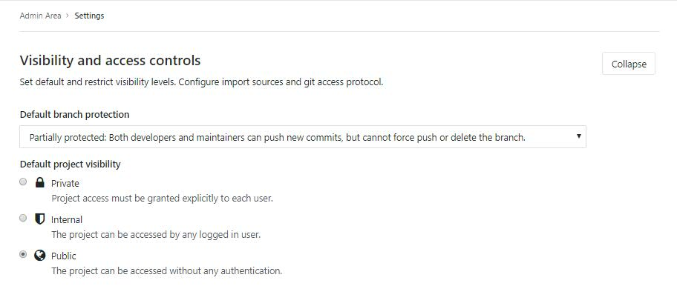

6. Nexus Deployment on Openshift

Follow below steps for Nexus deployment on Openshift:

Login into OpenShift UI console.

Click on Create Project button.



Fill up project details and click on Create button.

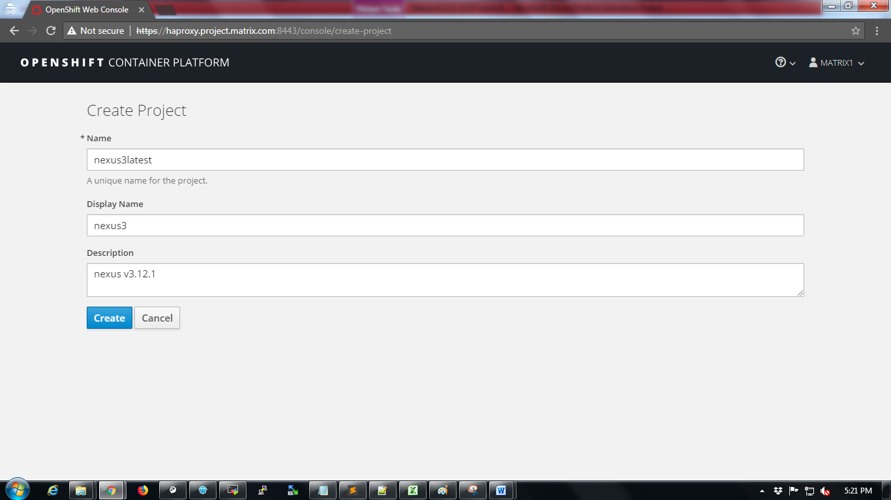

Next add the Nexus v3.12.1 template yaml file to your project.

Click on “Import YAML / JSON” tab and paste the content in attached template file on to the clipboard and Click on Create button.



A prompt “Add Template” will be displayed on screen then click on Continue button.

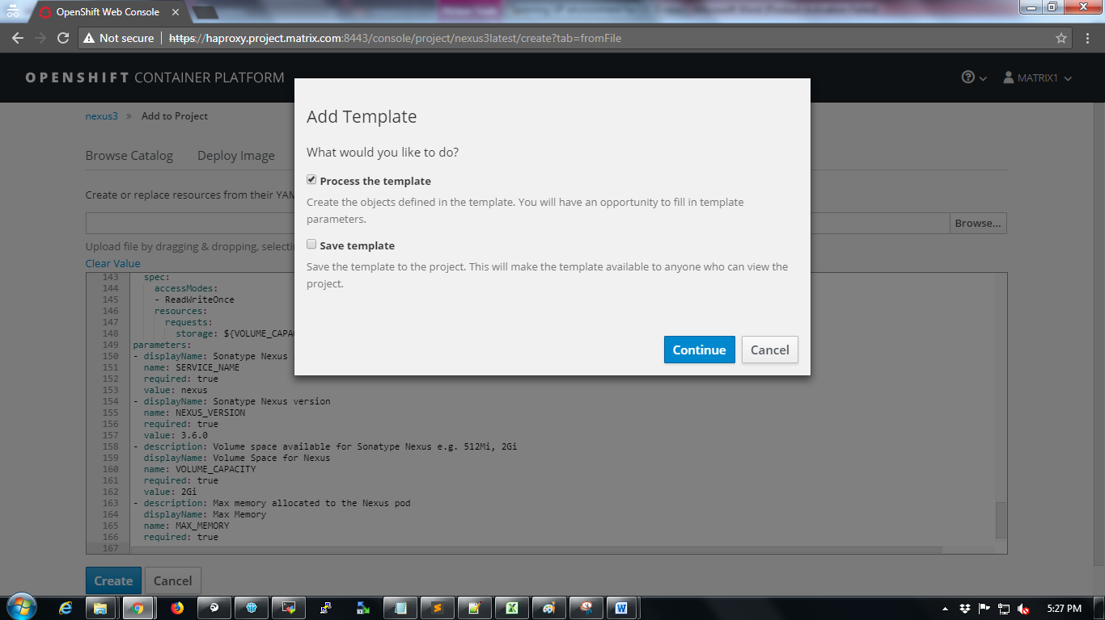

Configure Nexus container parameters as follows.

Change “Sonatype Nexus service name” field to any name like eg: nexusv3121

Set “Max Memory” field eg: 4Gi (for Nexus container with 4GB of RAM)

Set “Volume Space for Nexus” field eg: 20Gi (for Nexus container with 20GB of Disk Space)

Refer below screenshot for a sample parameter configuration.

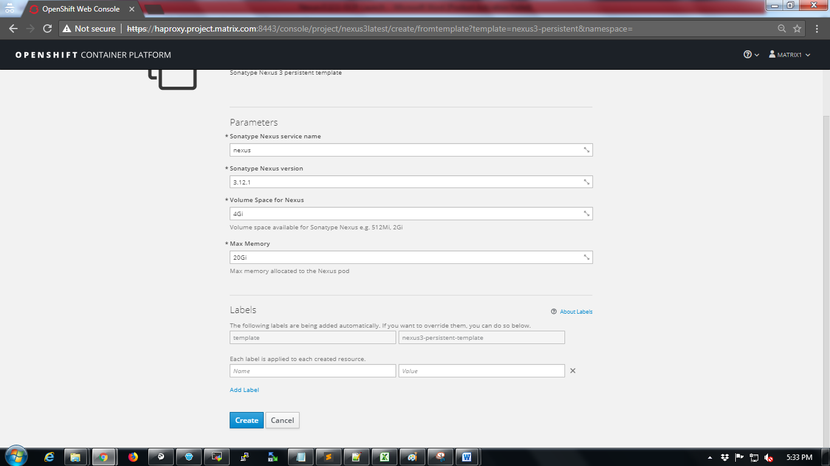

Click on Create button at the bottom of the page

The next page will show status that “Application created”.

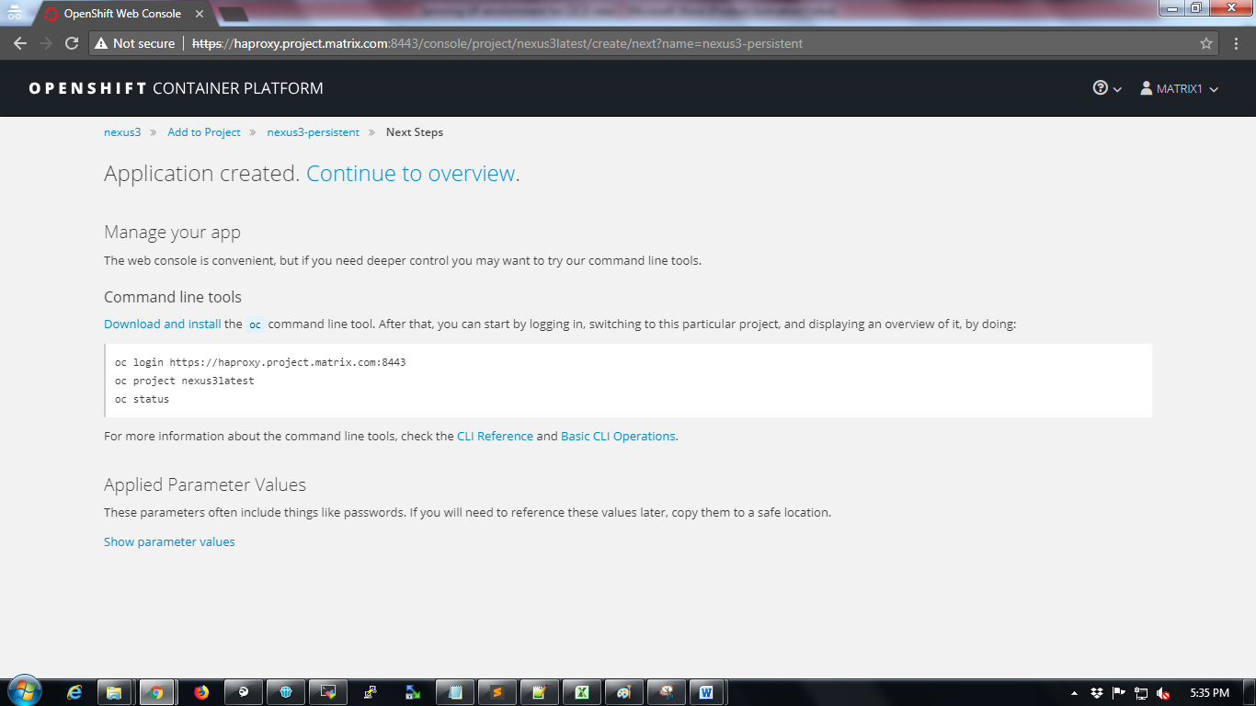

Wait for a while till the status shows “Completed” as shown below

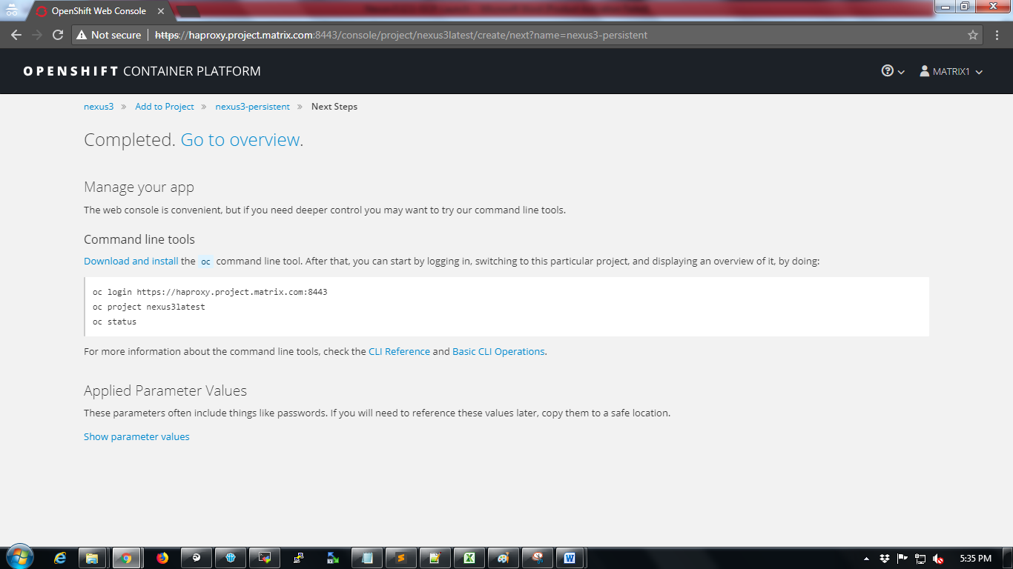

Click on “Go to overview” tab to verify the project home.

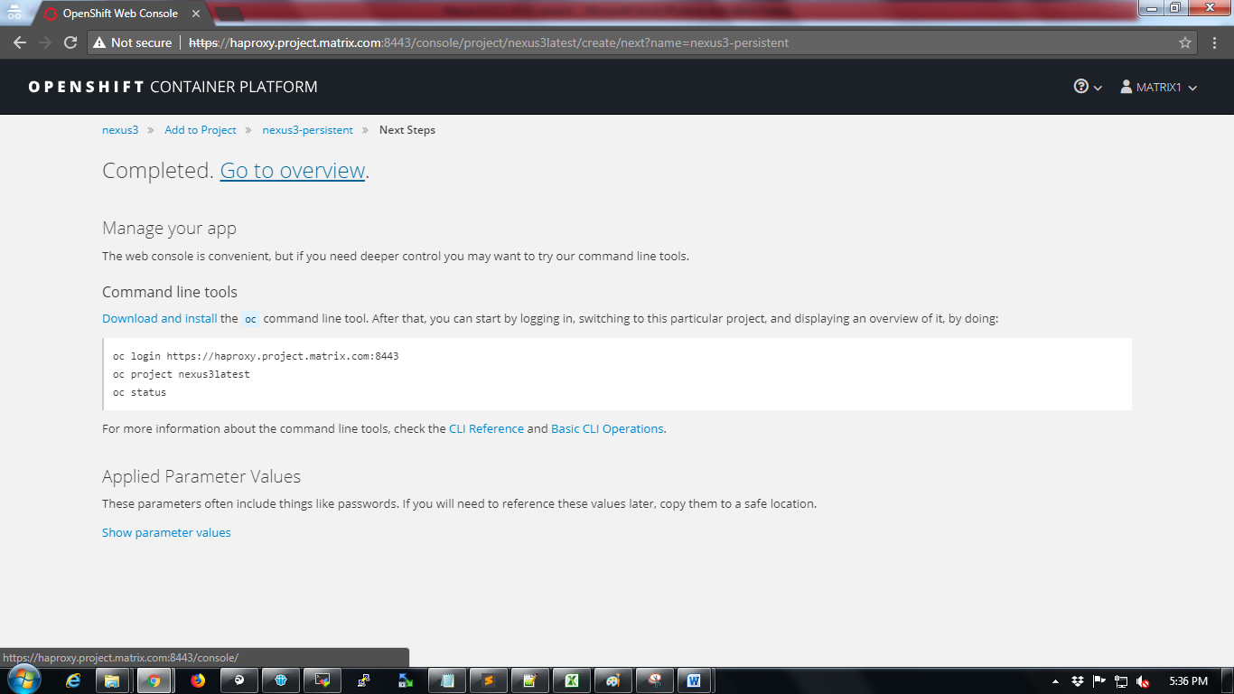

Access Nexus URL

To access Nexus follow below steps

Click on Applications🡪Routes

All routes accessible to Nexus will be displayed.

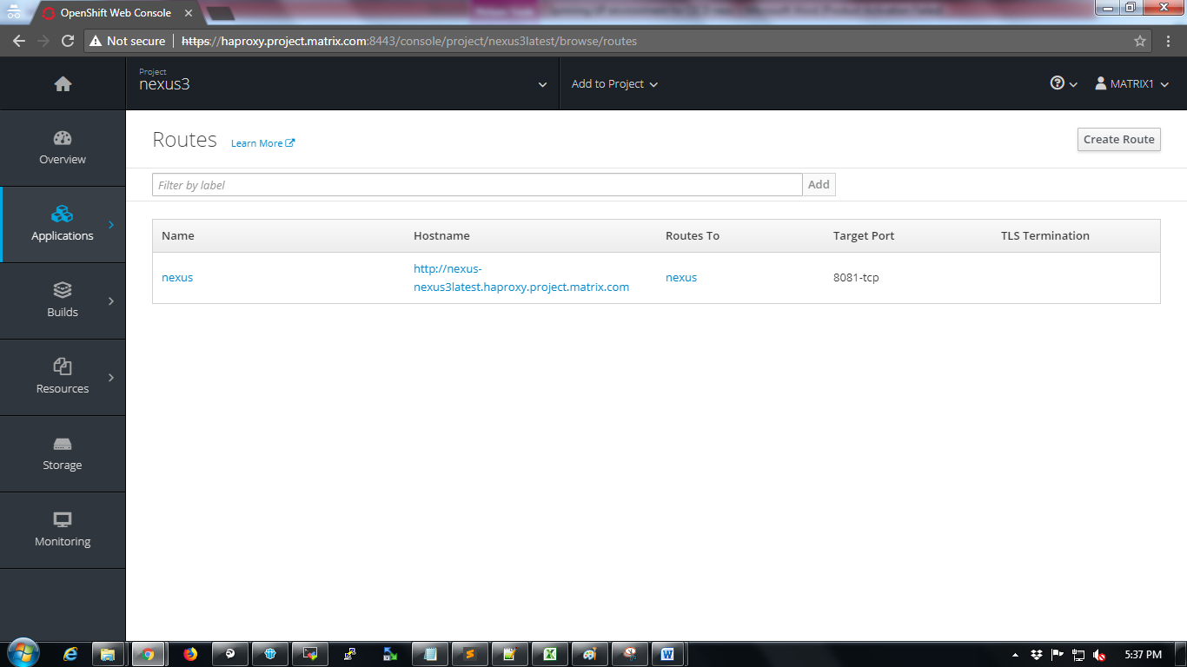

Now copy the hostname as highlighted in below screenshot and add to local computer’s hosts file to access using browser. While adding the hostname in hosts file make sure it is mapped to proper haproxy address of OCP.

Refer below screenshot

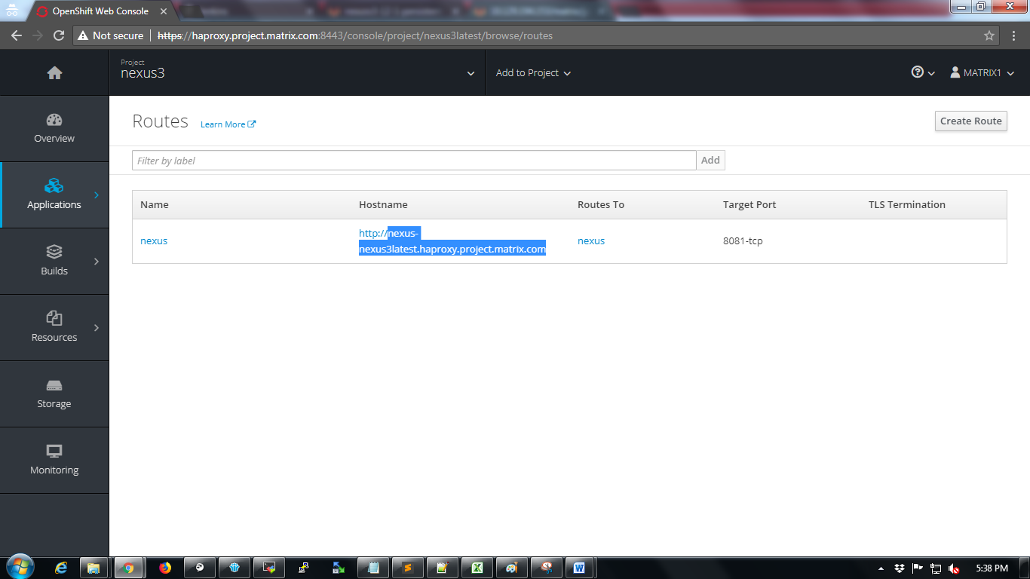

Now try to access the application using the url and login with default credentials of nexus. Click on “Sign in” button.

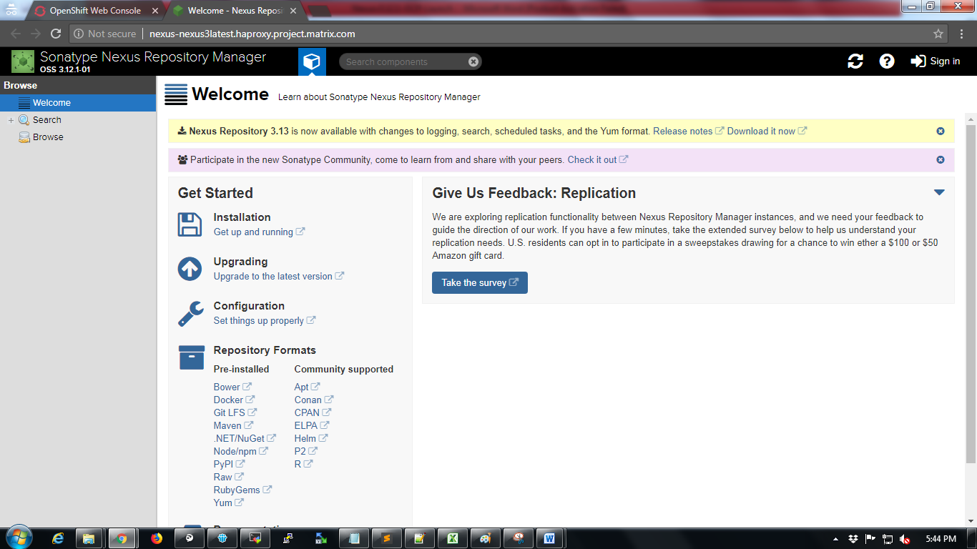

Default Credentials:

Username: admin

Password: admin123

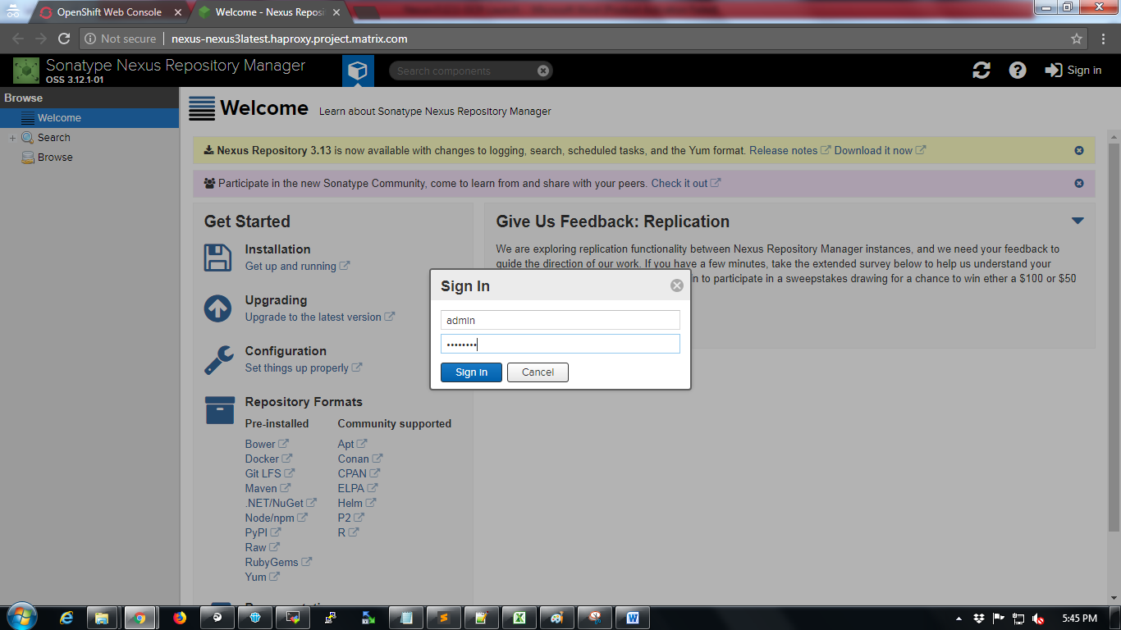

Create user in nexus

Click on settings icon 

Click on Users option

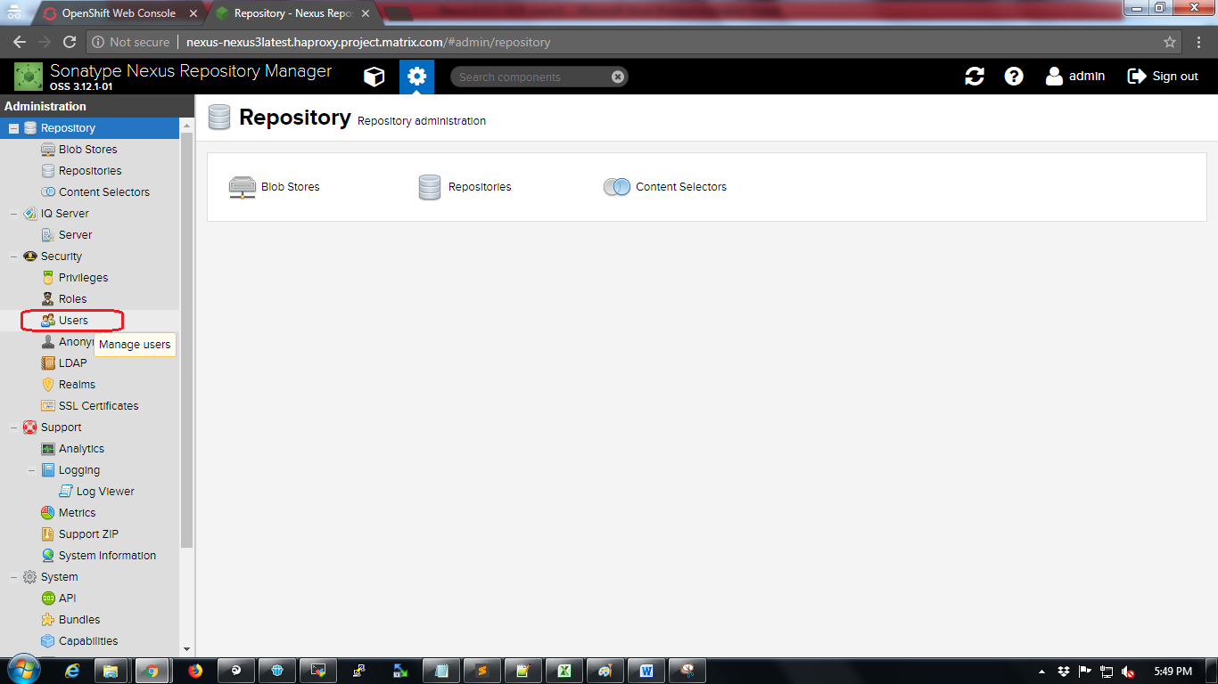

Click on “Create local user”

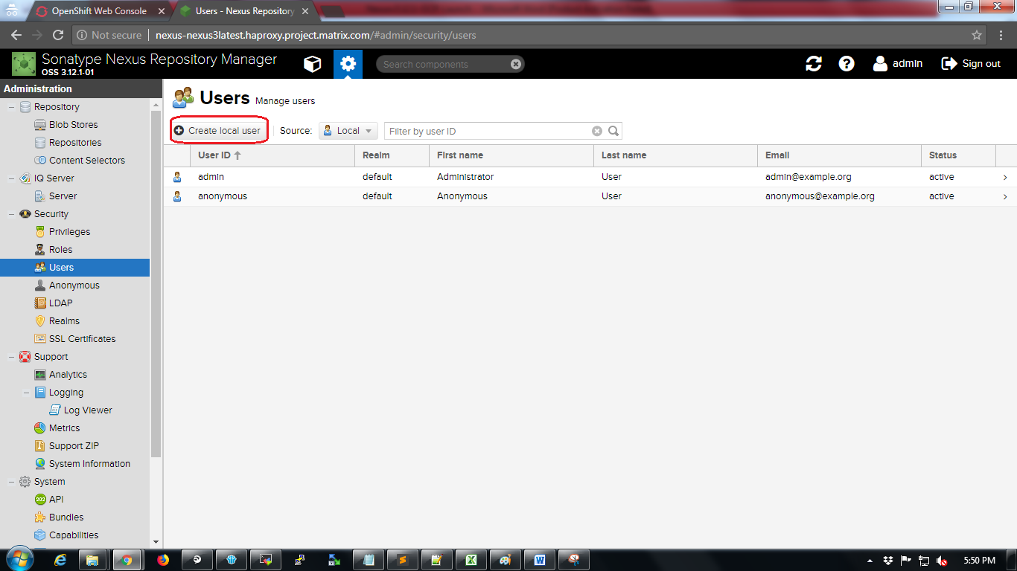

Provide information in the mandatory fields and click on “Create local user” button.

Refer screenshot below for sample configuration.

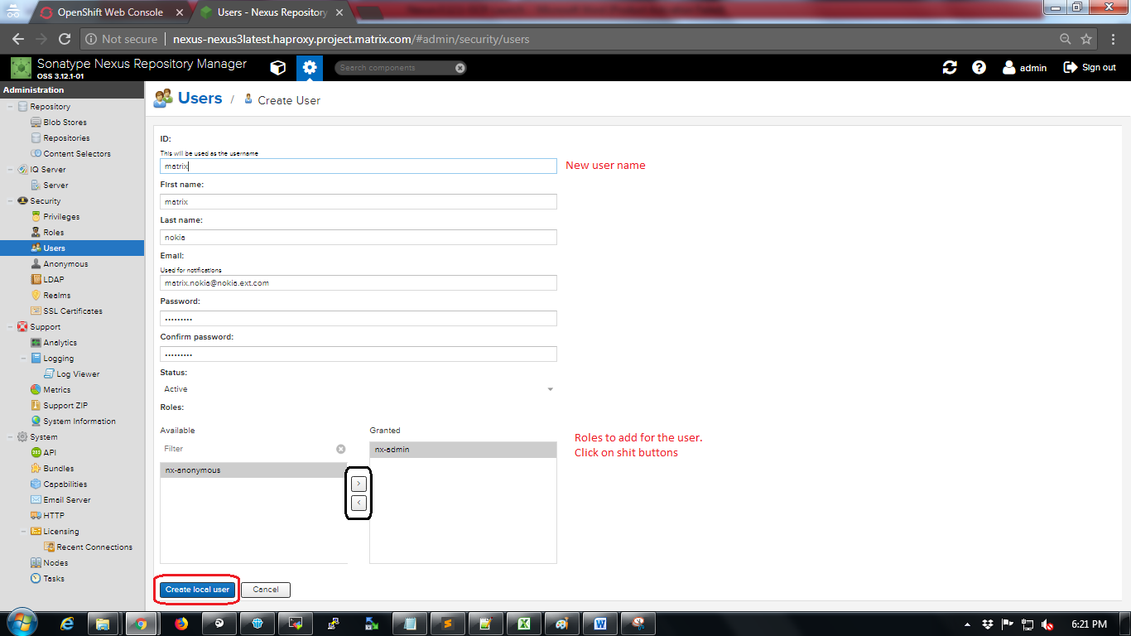

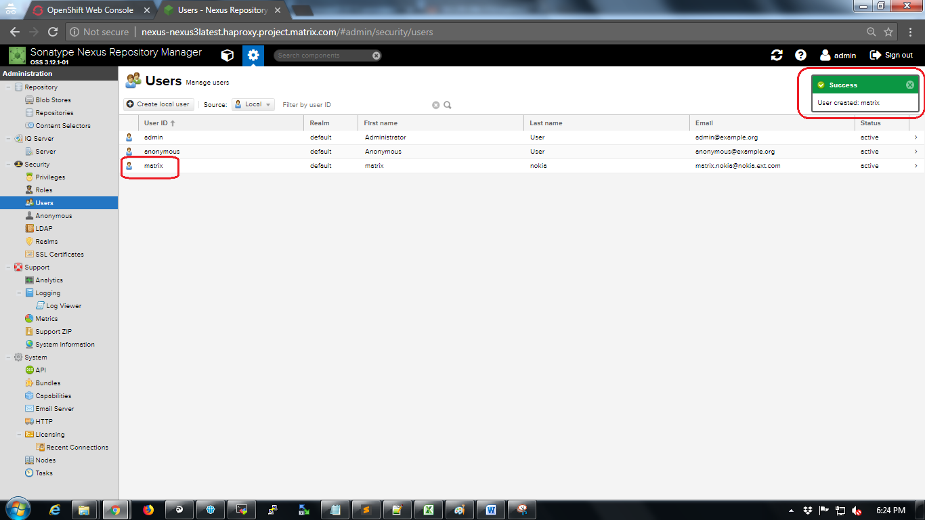

Create Roles for new user.

Click on “Roles” option

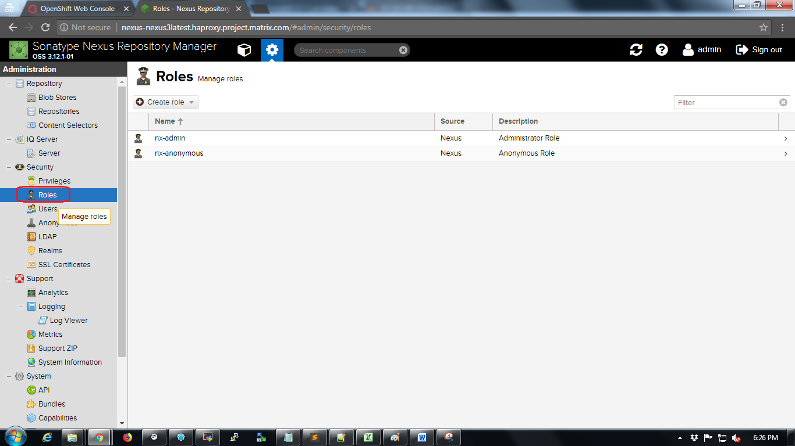

Click on “Create role” dropdown and select Nexus Role

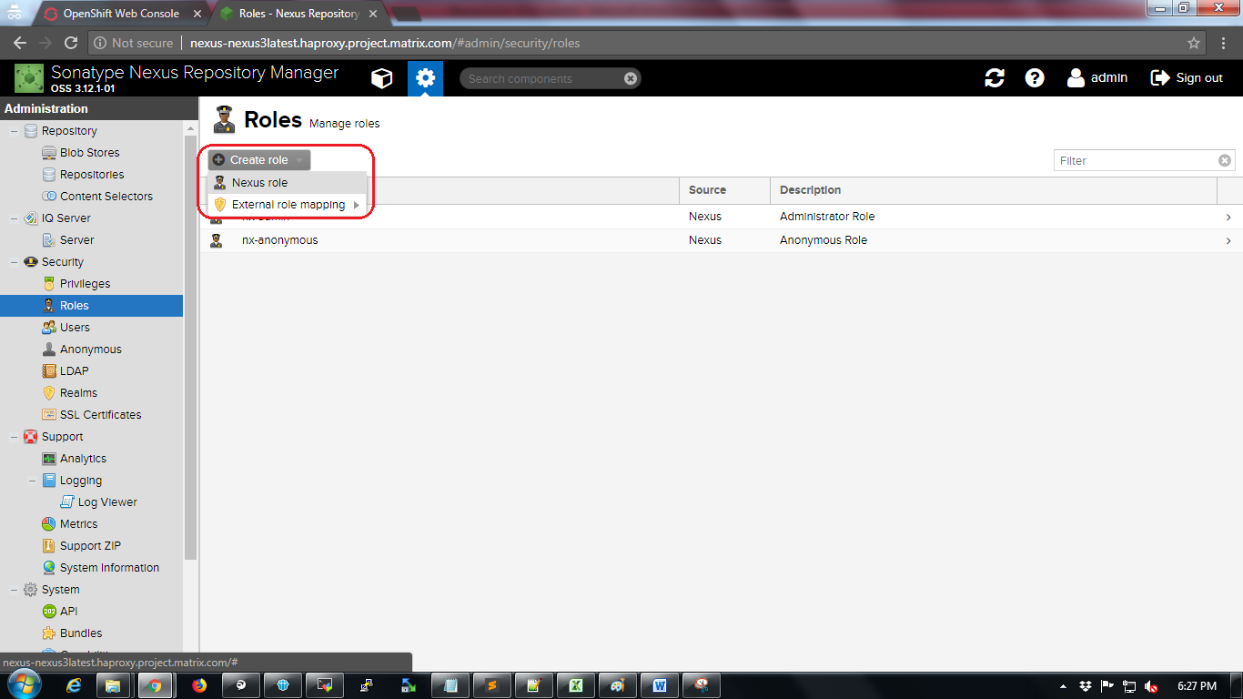

Configuring role and adding privileges to the role as shown in below screenshot and click on “Create role”.

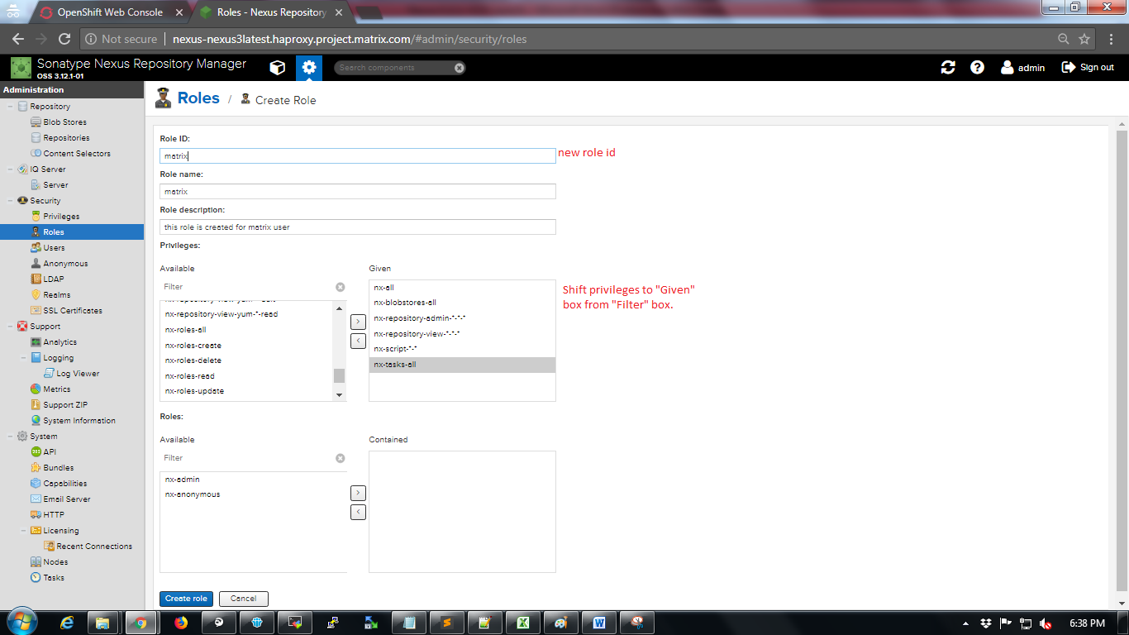

Click on “Users” option again and click on new user name “matrix”. Assign new role to new user.

Click on “Save” button. User updated successfully popup will be displayed on top right of the screen.

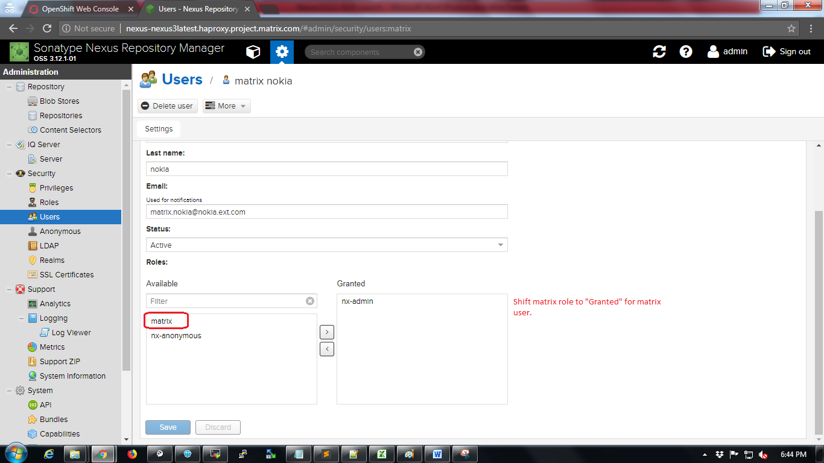

Sign out from admin login and login using new user name and password

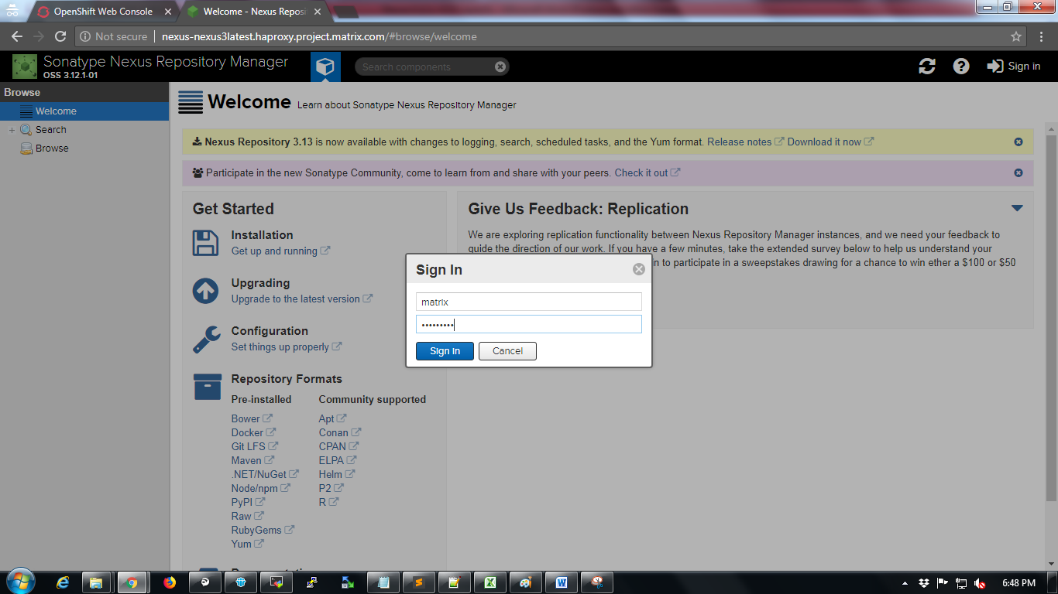

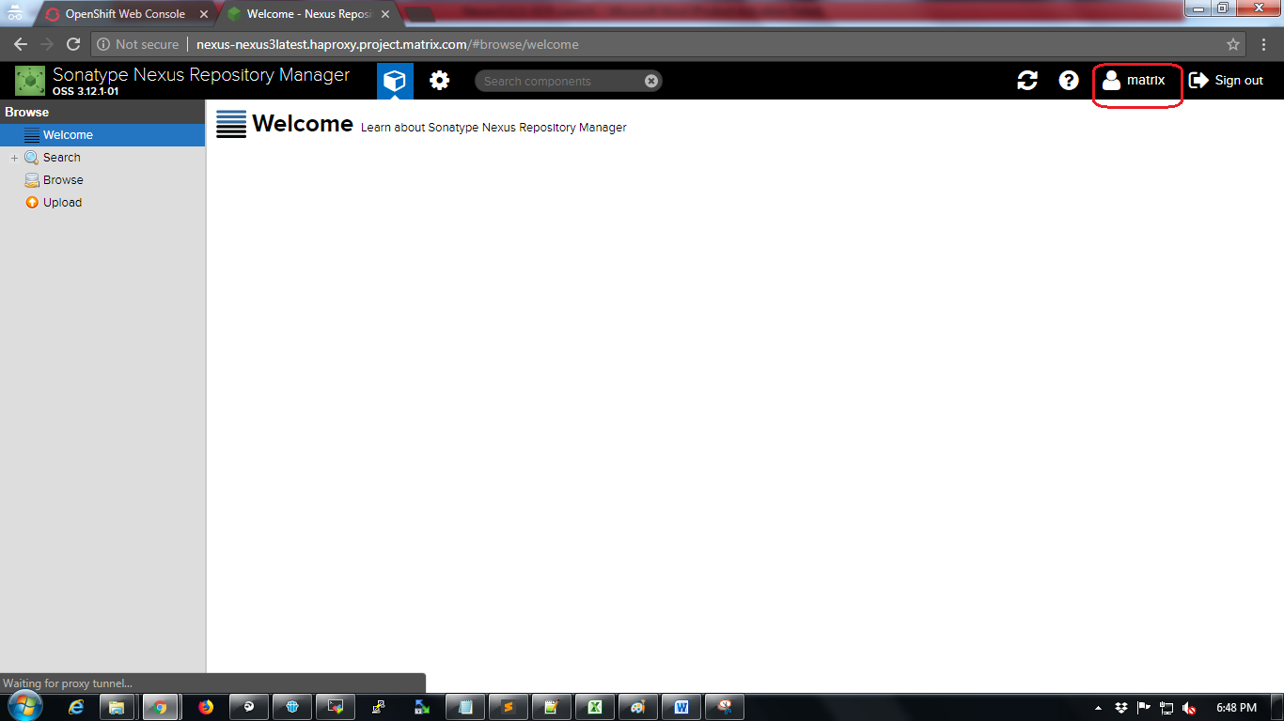

To verify that user has enough permission to create repository

Click on settings icon 

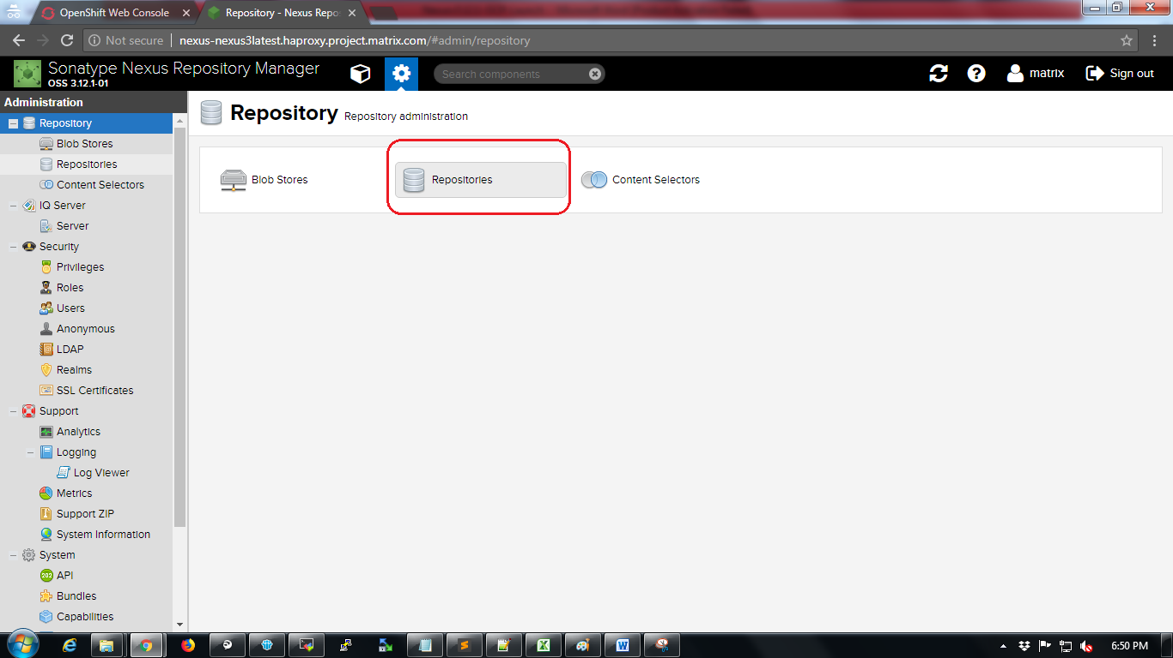

Click on “Create repository” button

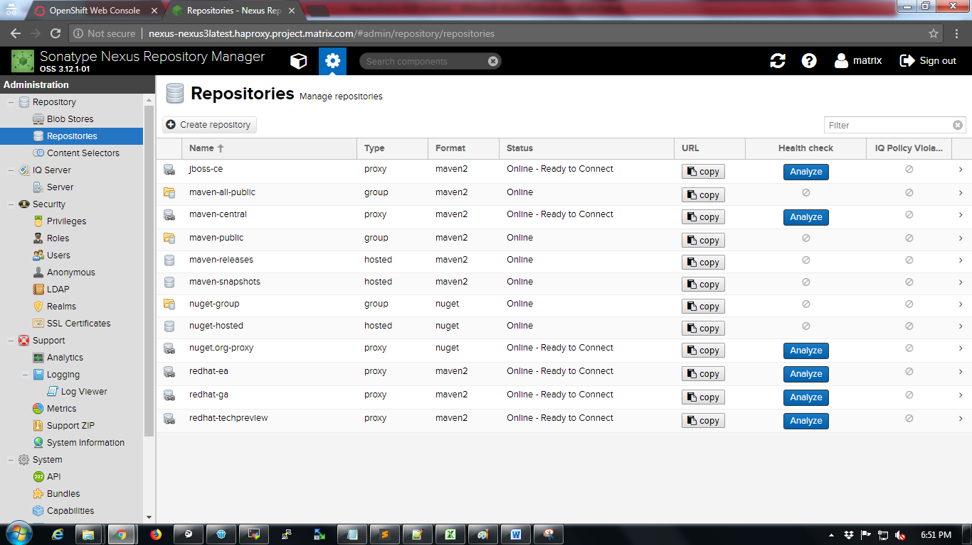

Select any repository type

Eg: maven2 (hosted)

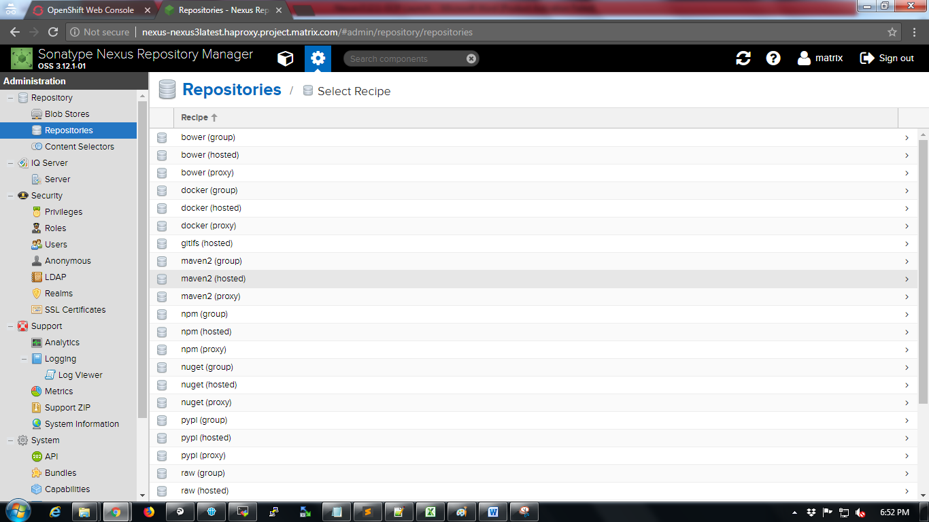

Configure new repository

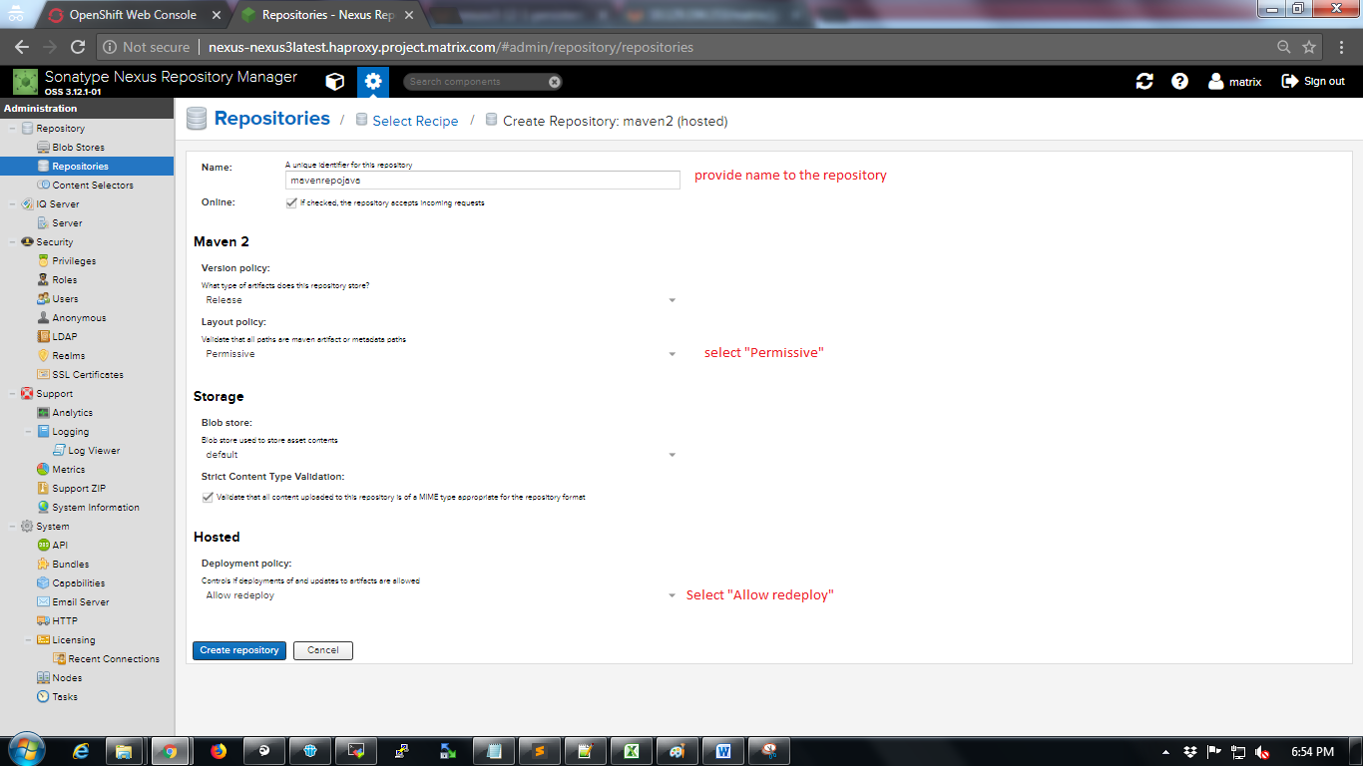

Click on “Create repository” button.

New repository will be created.

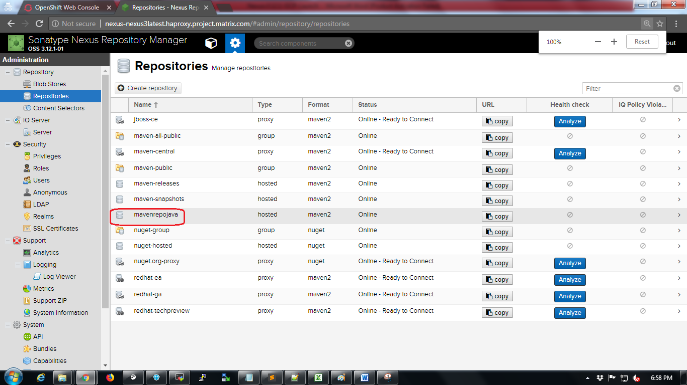

So it is verified that User has enough permission to create repositories.

1. SonarQube Deployment on Openshift

Follow below steps for Sonarqube deployment on Openshift:

Login into OpenShift UI console.

Click on Create Project button.



Fill up project details and click on Create button.

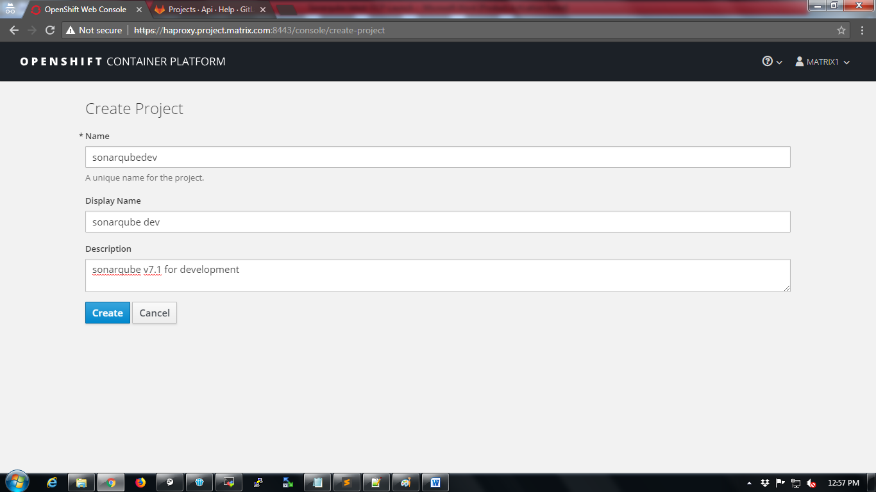

Click on “Deploy Image” tab.

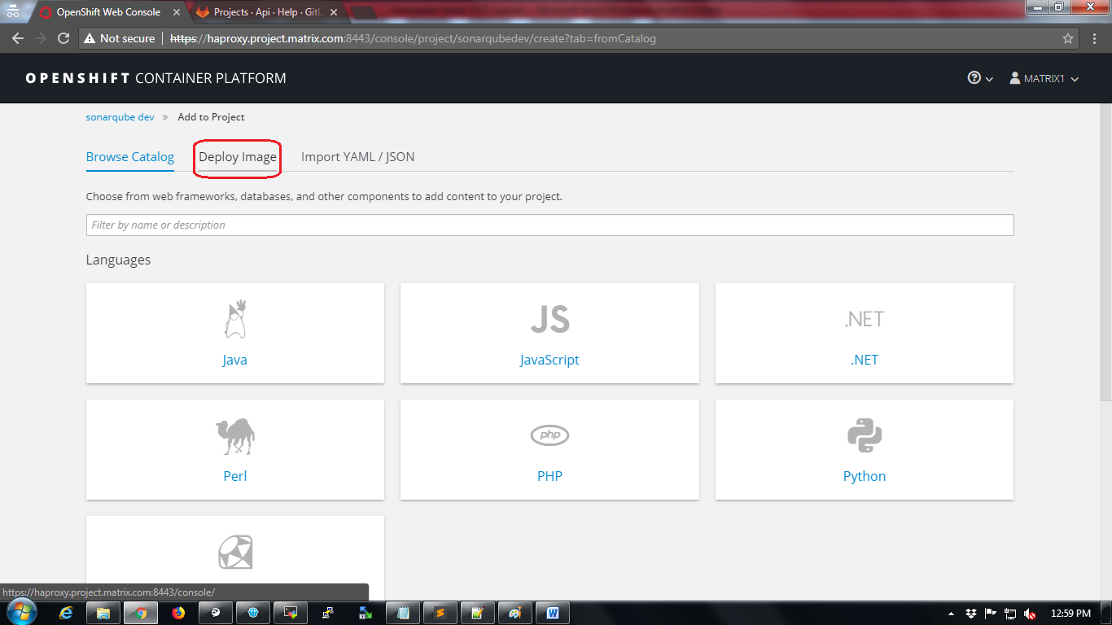

Select “Image Name” radio button and type “docker.io/sonarqube:7.1” in the search box and click on search button as shown in the below screenshot

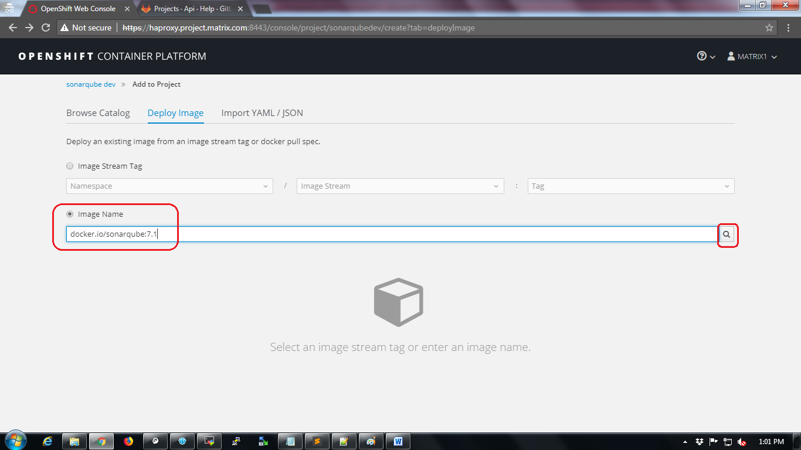

After clicking on search button sonarqube resources will be created as per the image as shown in the below screenshot.

Click on “Create” button.

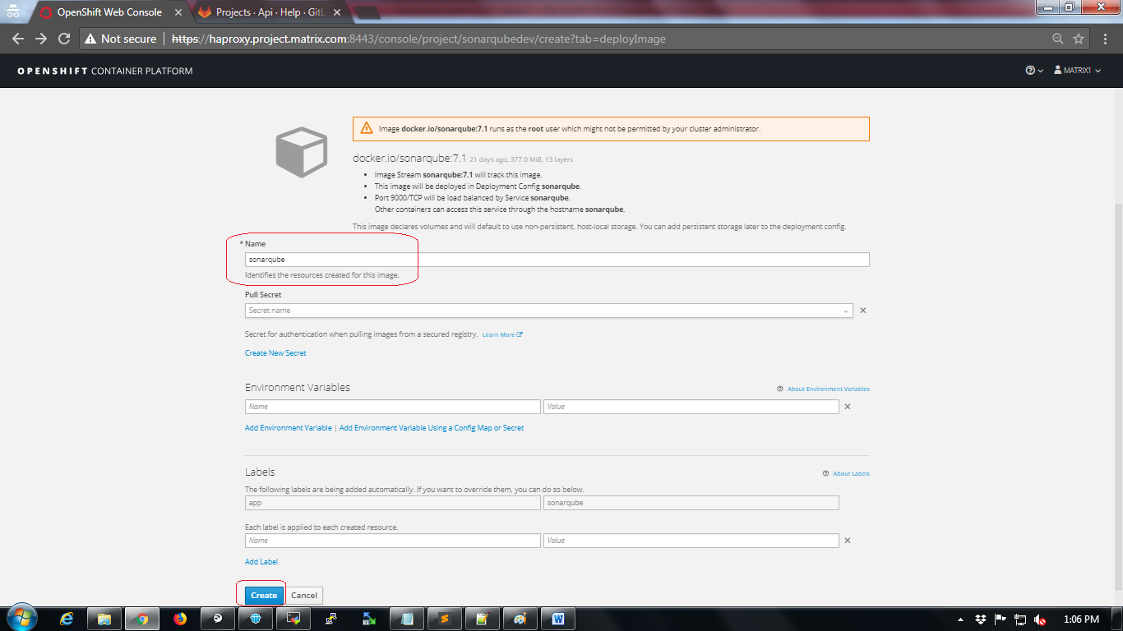

The next page will show status that “Application created”.

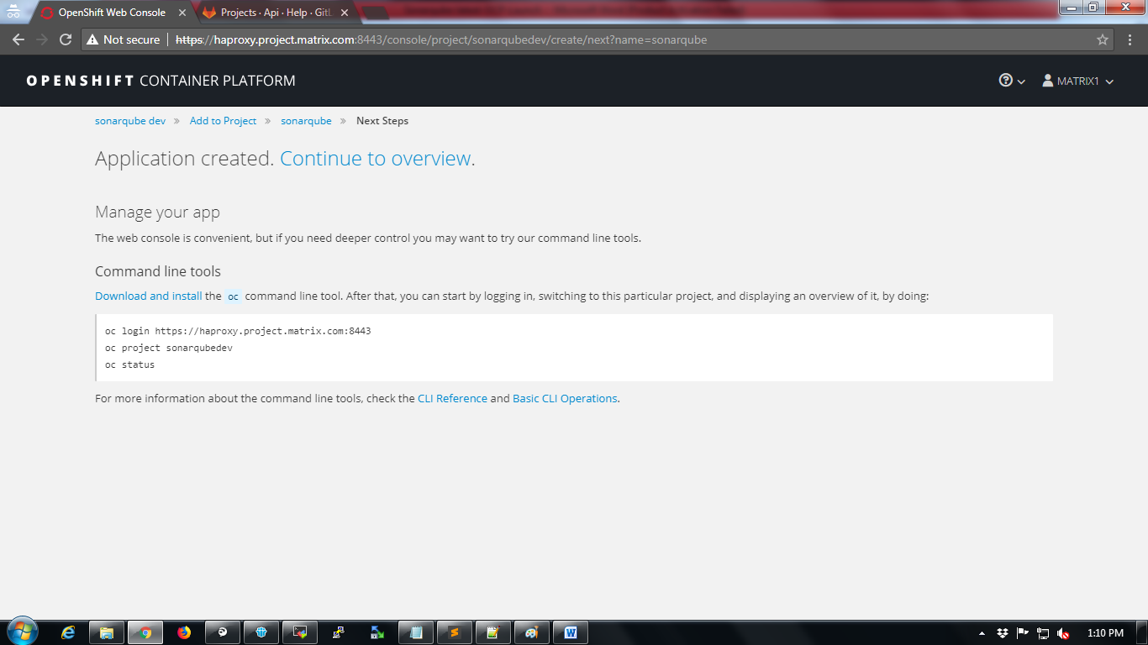

Wait for a while till the status shows “Completed” as shown below

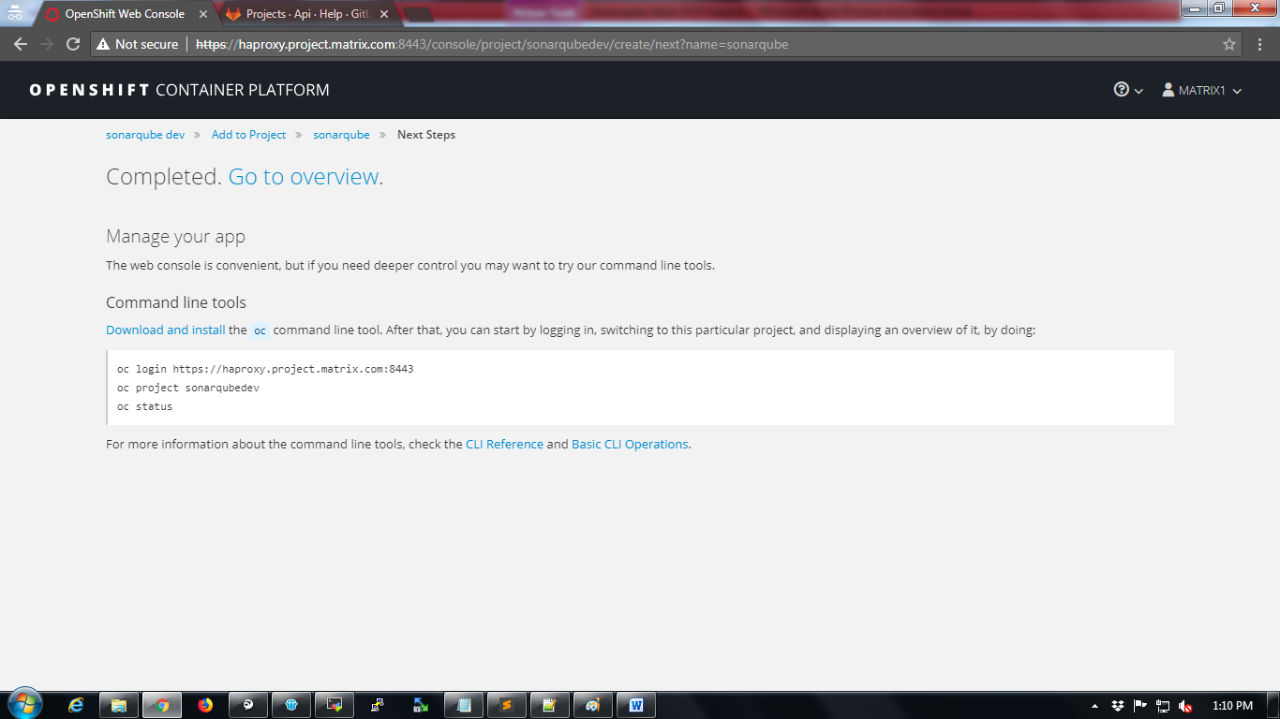

Click on “Go to overview” tab to verify the project home.

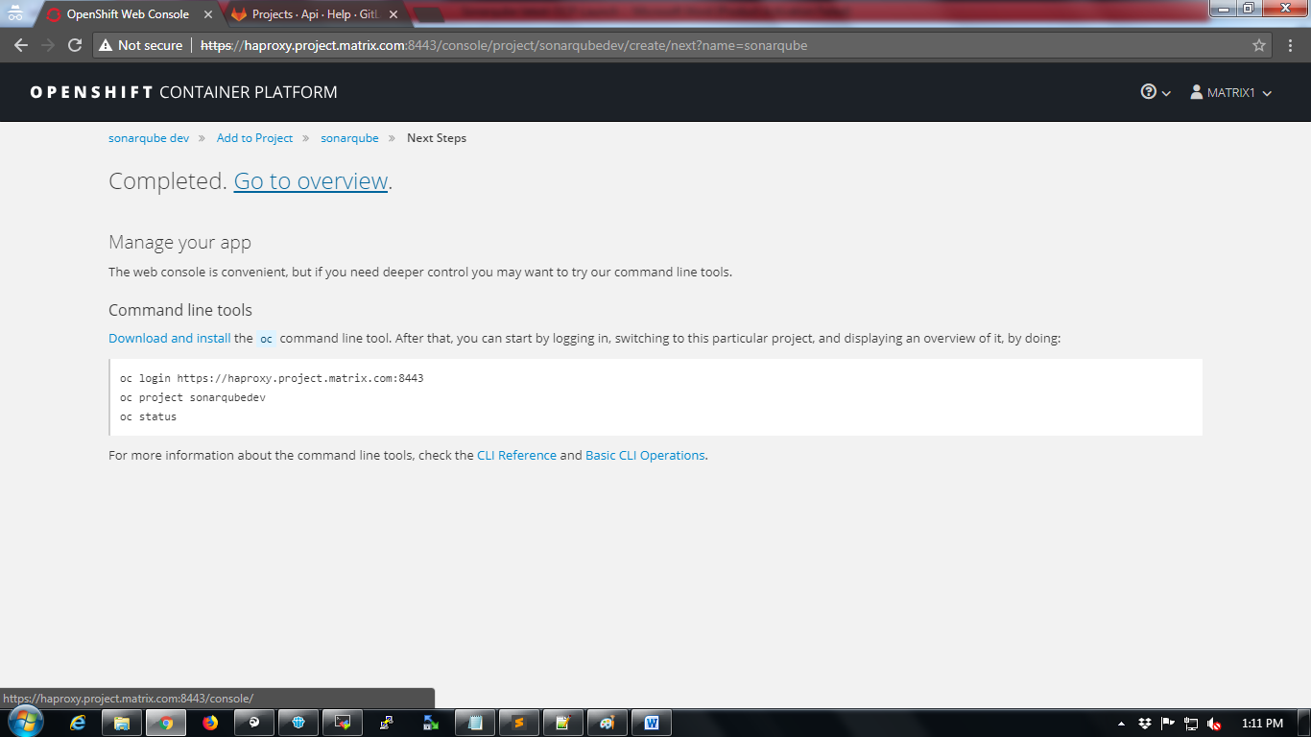

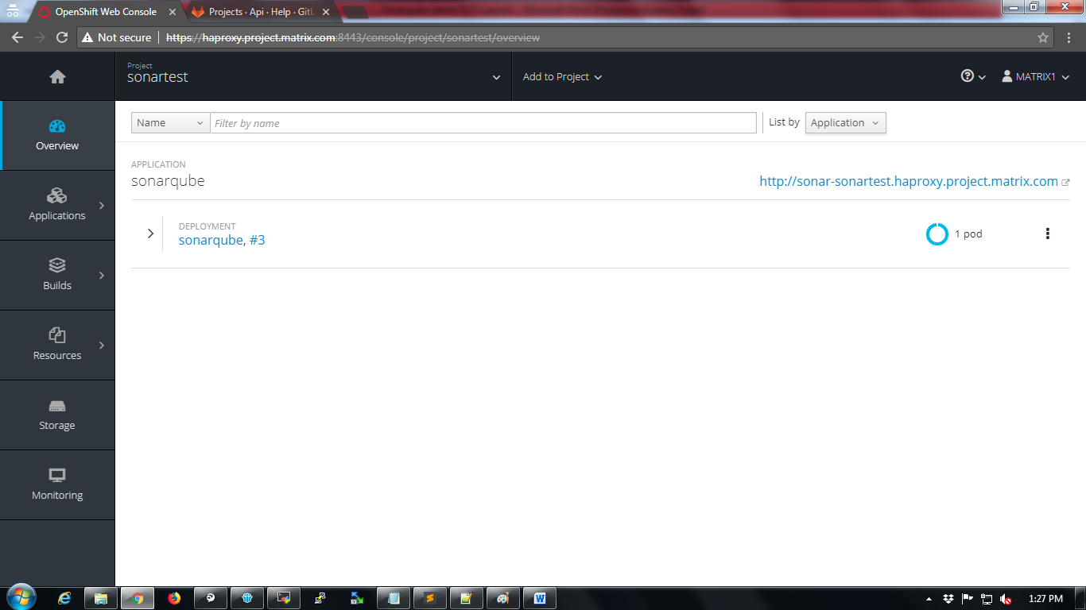

## Adding Root permissions to OCP service

OCP services may require root privileges for applications. The root privileges can be implemented using “userroot” service in OCP.

To add “useroot” privileges

1. Login into any master node VM of OCP
2. Select the project

# oc project sonartest

1. Create userroot service account

# oc create serviceaccount useroot

1. Add useroot policy

# oc adm policy add-scc-to-user anyuid -z useroot

1. Get the dc name

# oc get dc

1. Patch the useroot account using dc name

# oc patch dc/<dcname> --patch '{"spec":{"template":{"spec":{"serviceAccountName": "useroot"}}}}'

1. Refer screenshot below

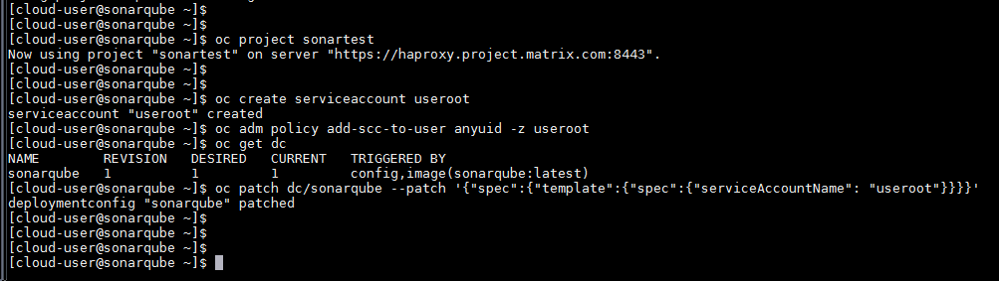

## Adding persistent storage to sonarqube

Persistent storage will store the application data even if pod in OCP restarts/crashes

Click on “Storage” option to create persistent storage

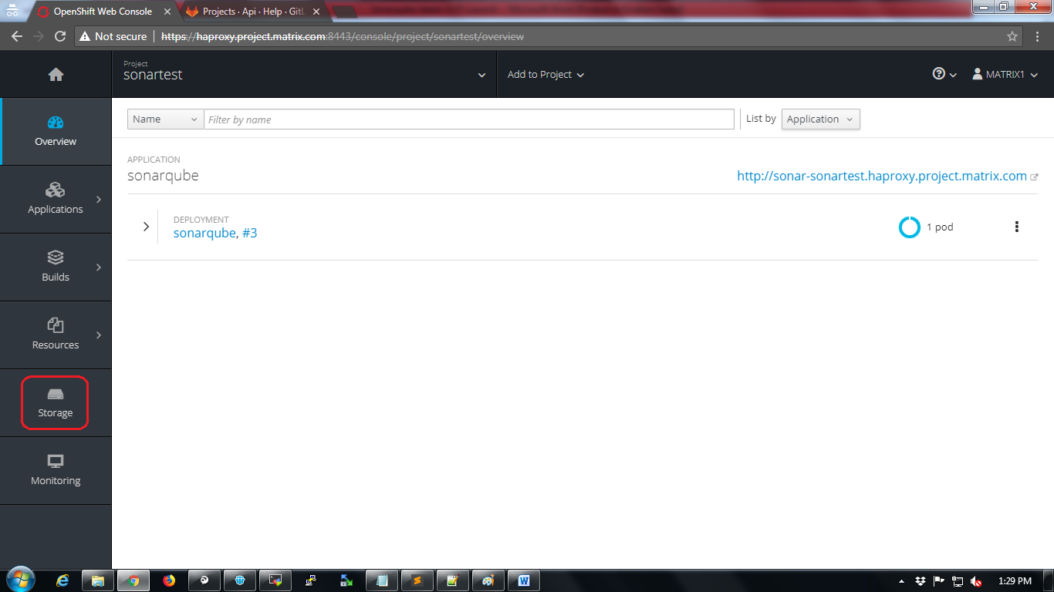

Click on “Create Storage” button.

Provide mandatory storage configuration details and click on “Create” button.

Refer screenshot below for sample configuration.

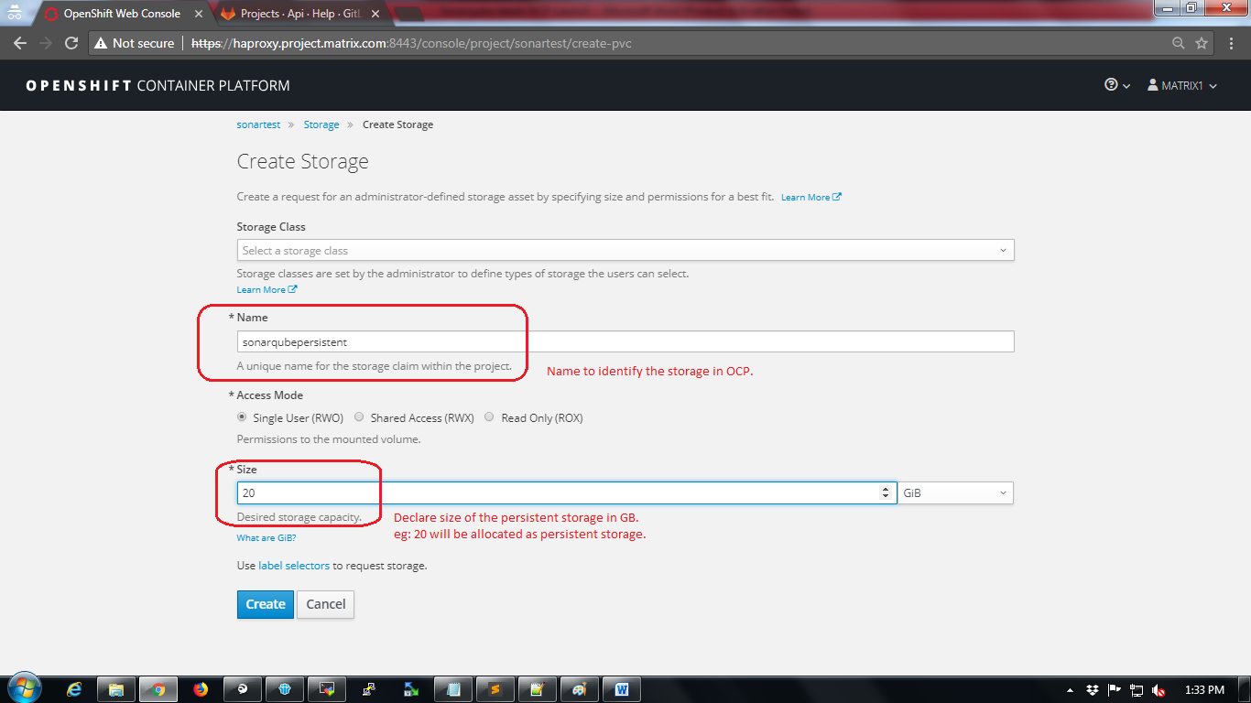

Storage will be displayed after creation.

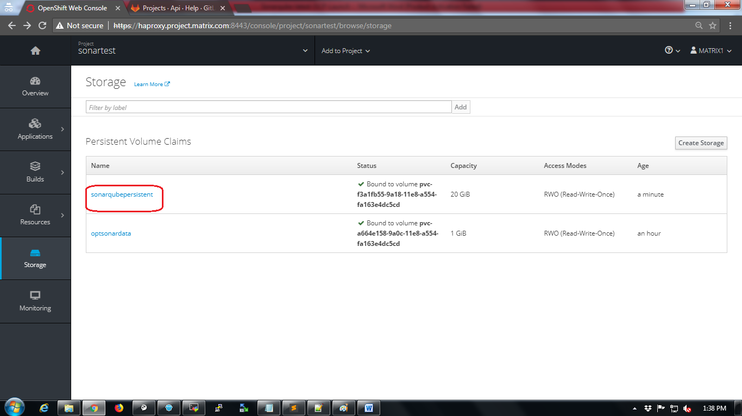

Now the storage should be added to the deployed image.

Click on Applications🡪 Deployments

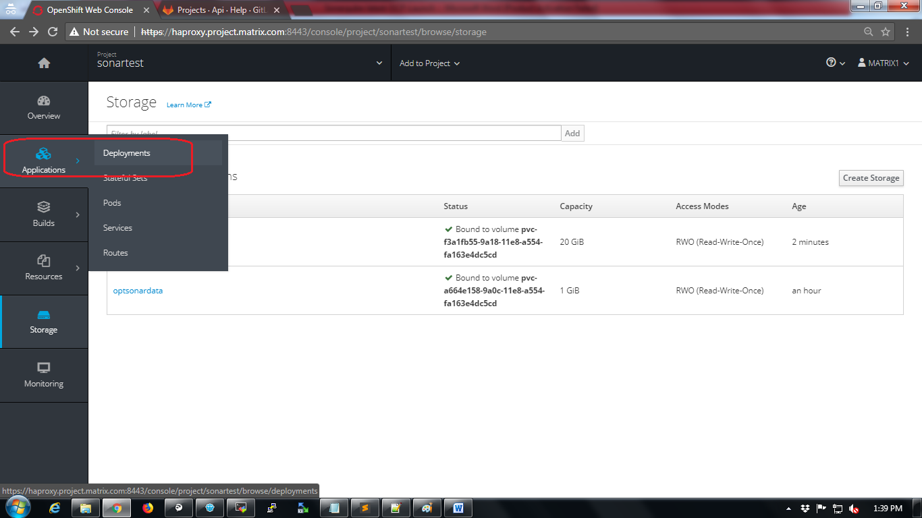

Click on name of the deployment as shown in below screenshot

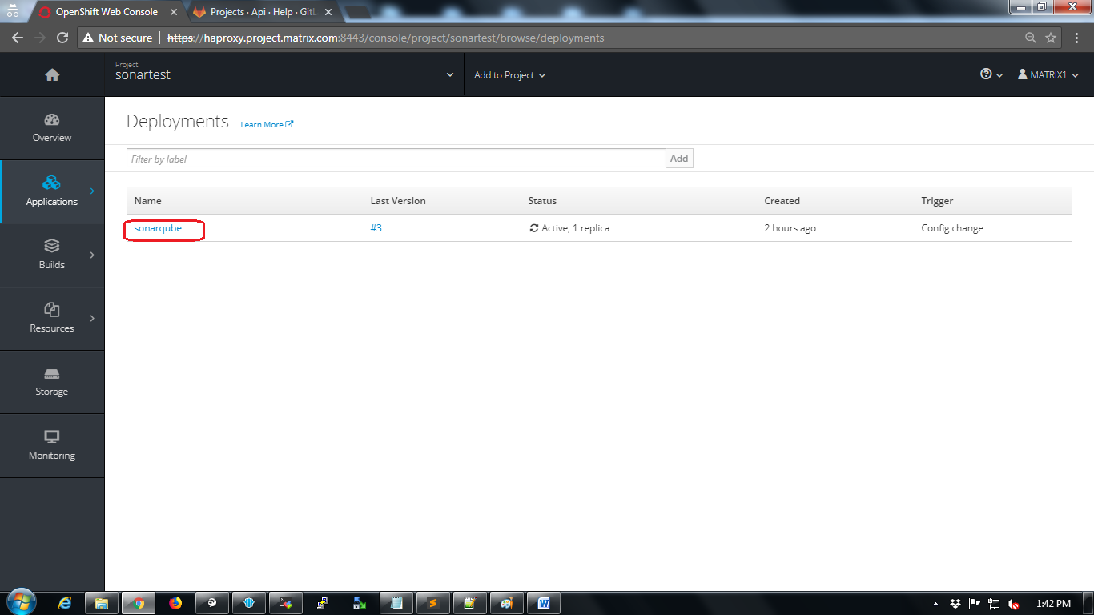

Click on “Actions” dropdown and select “Add Storage” option.

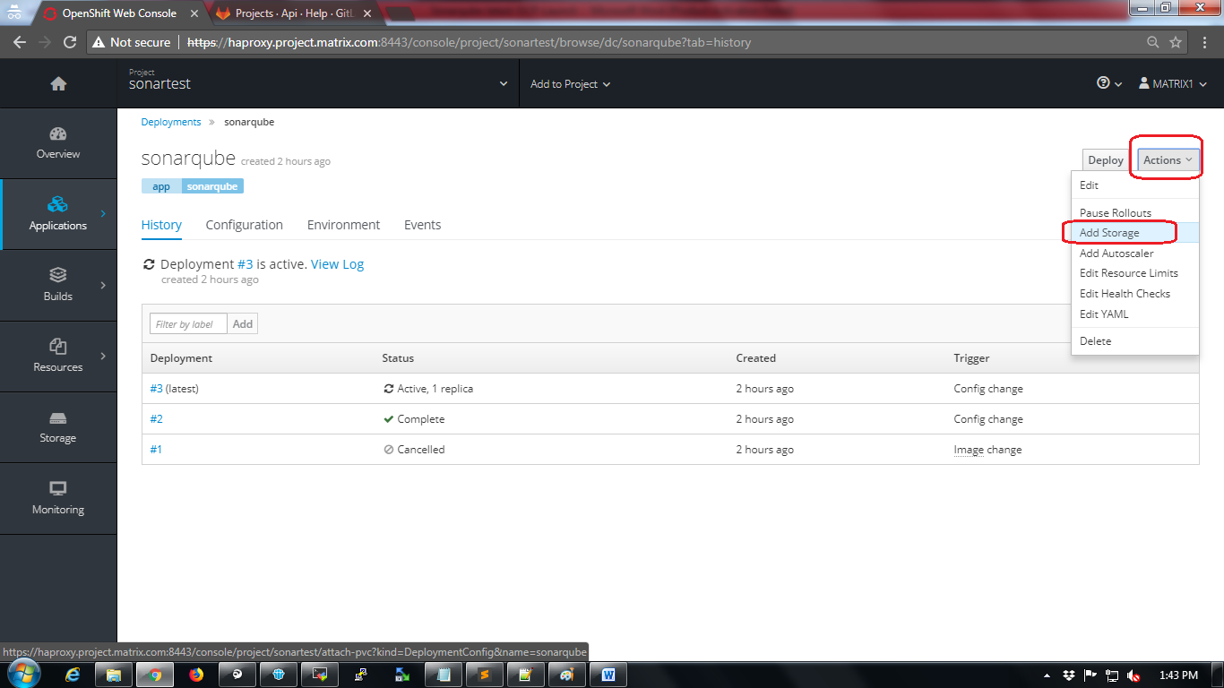

Select the storage the one which was created in previous step.

Provide mount path details and make sure to add “Mount Path” as “/opt/sonarqube/conf” as mentioned in the screenshot below.

Click on “Add” button.

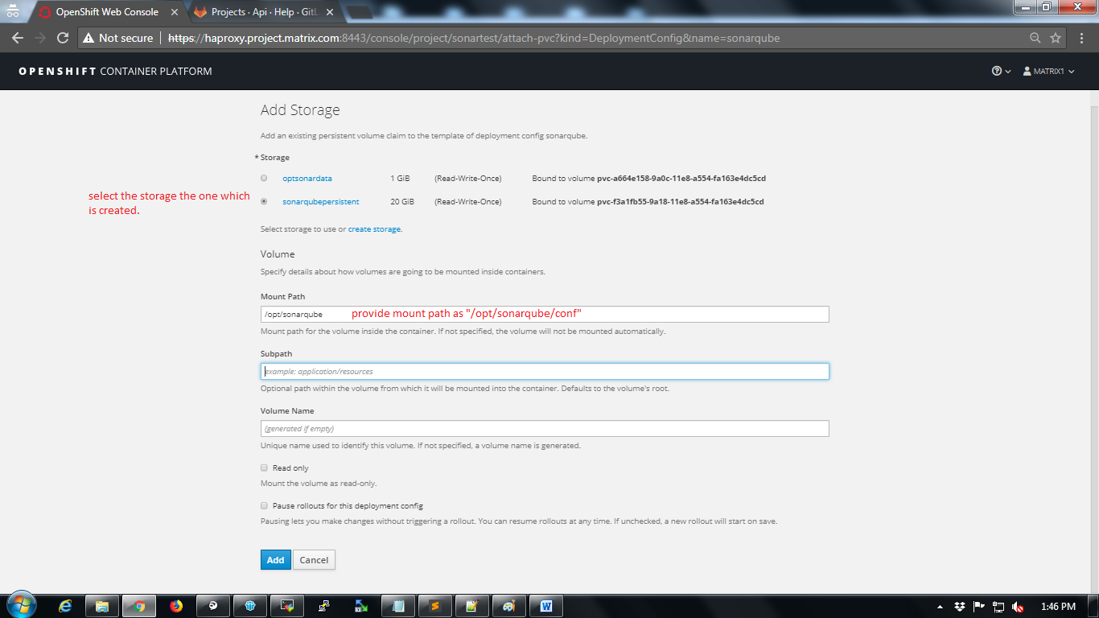

The moment storage is added the pod will restart and will be created with new configuration (persistent storage).

Wait for the pod to recreate

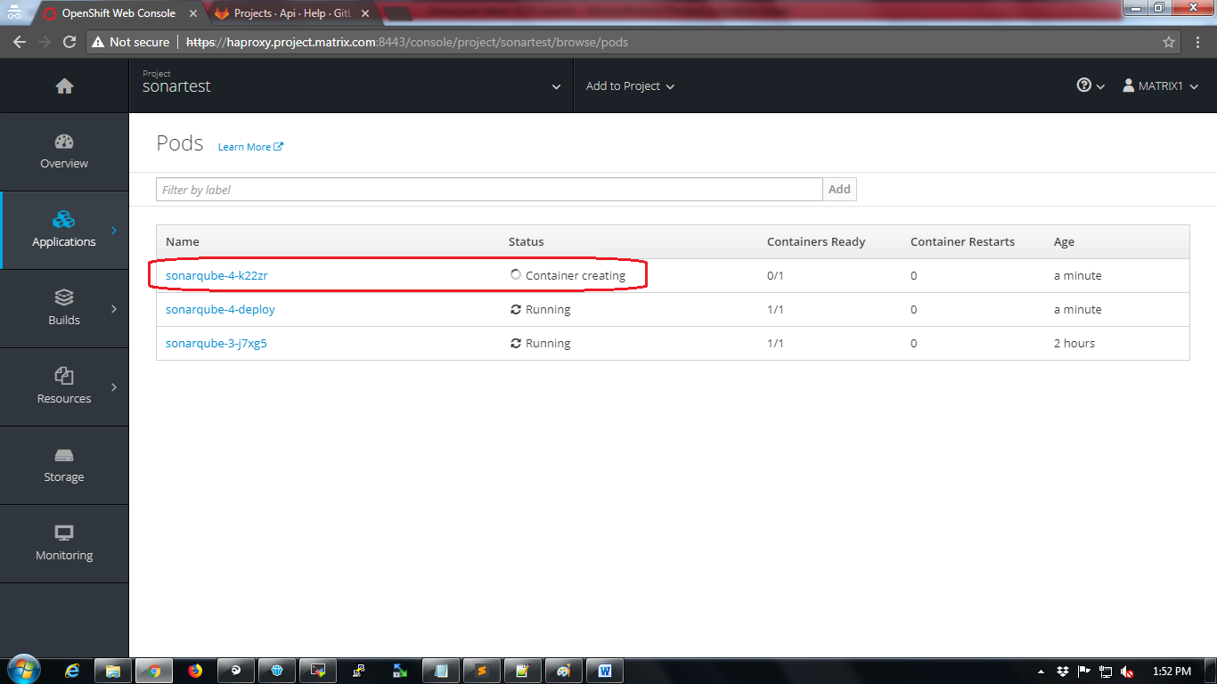

Access the sonarqube UI

Click on Applications🡪Routes

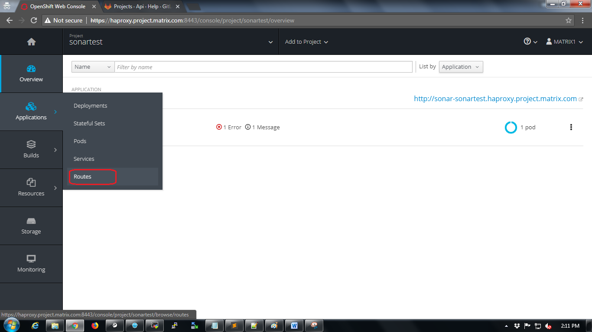

Click on “Create Route” button

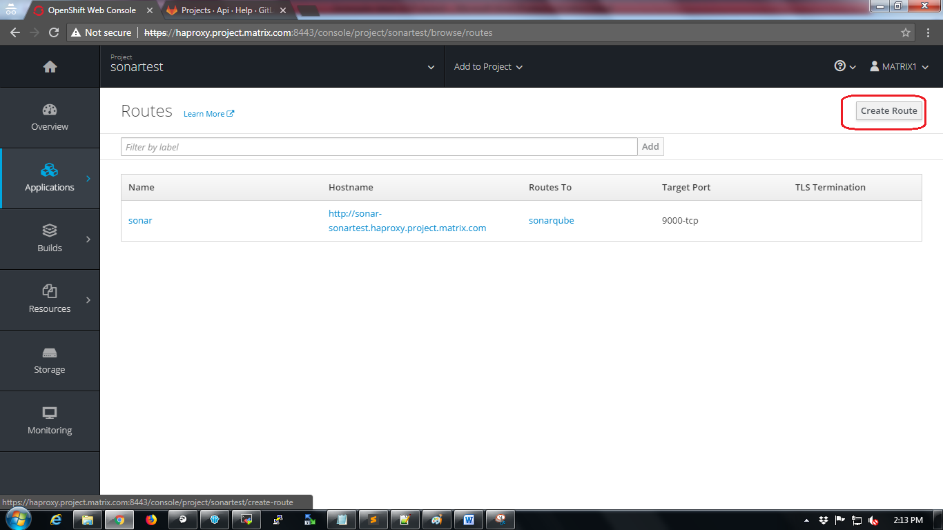

Provide name to the new route and click on “Create” button.

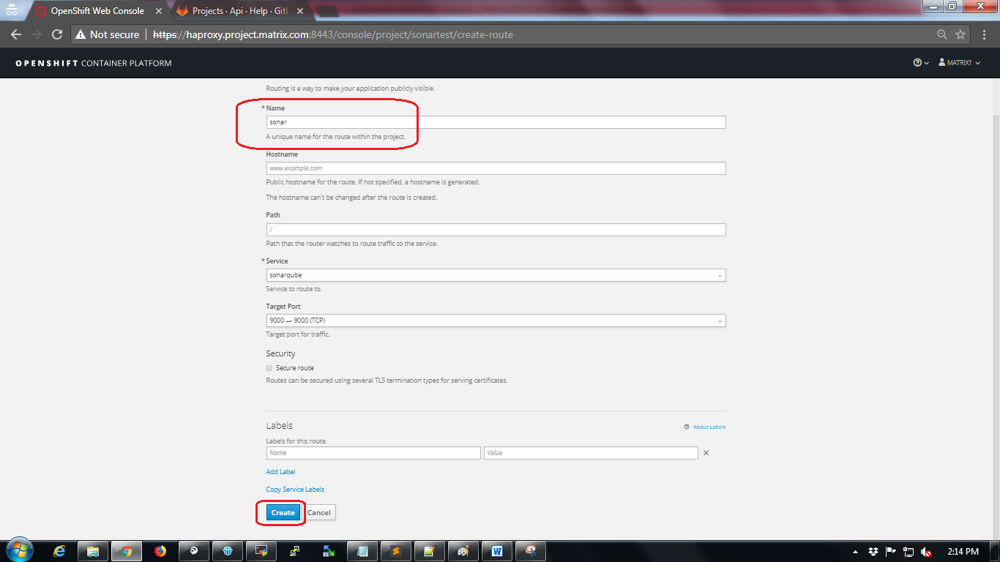

After route is created it will be displayed.

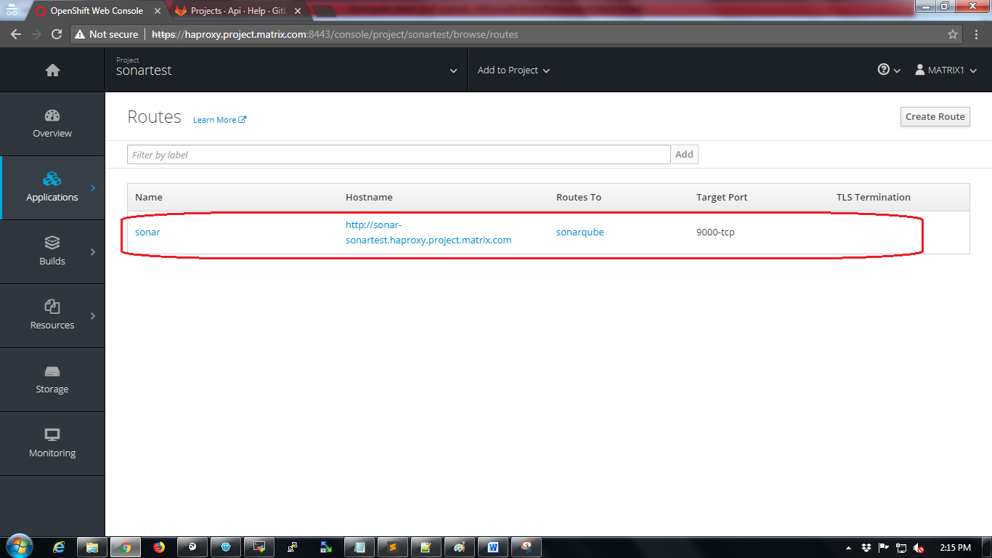

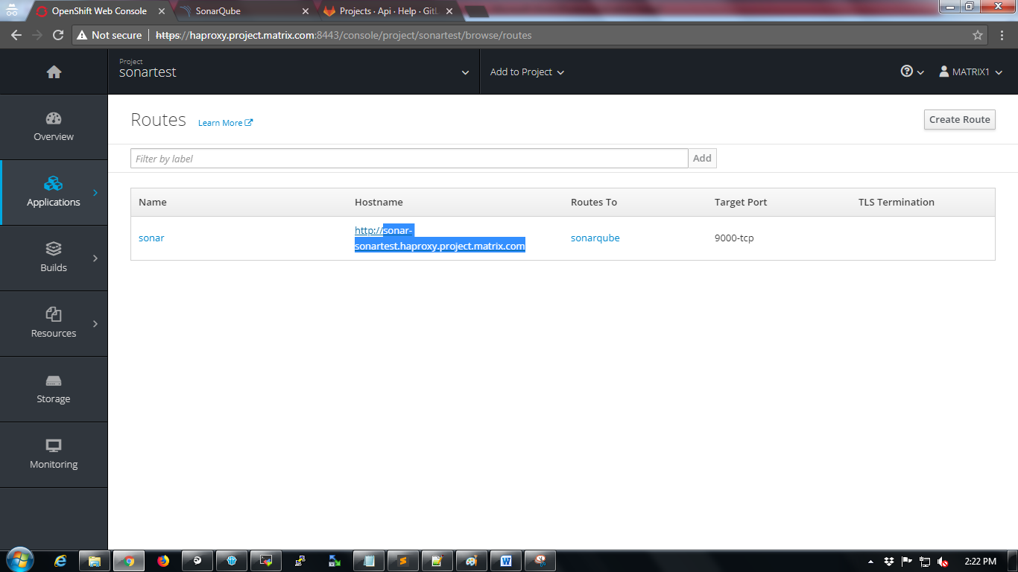

Now copy the hostname as highlighted in below screenshot and add to local computer’s hosts file to access using browser. While adding the hostname in hosts file make sure it is mapped to proper haproxy address of OCP.

Now try to access the application using the url.

Sonarqube UI will be shown as in the below screenshot.

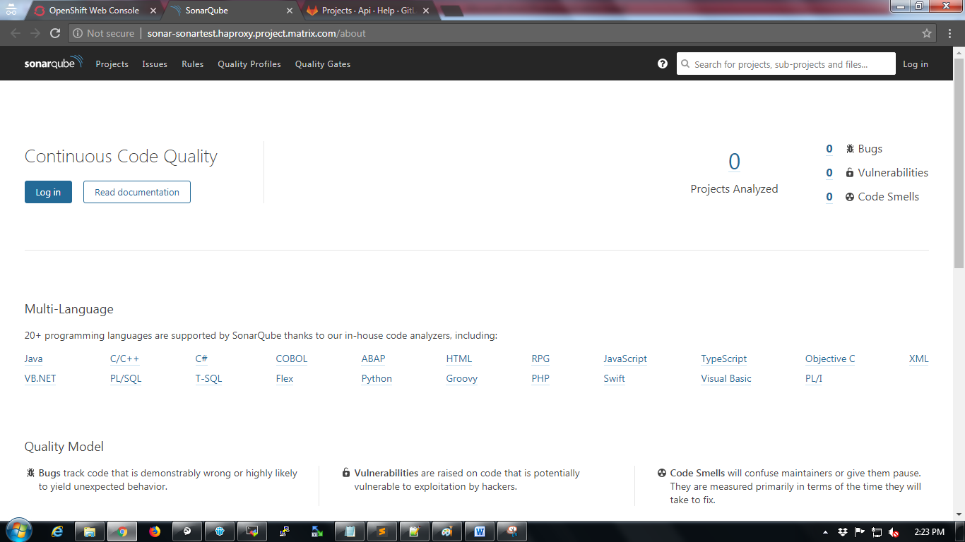

## Installing plugins in SonarQube

Login into sonarqube with default admin credentials

Username: admin

Password: admin

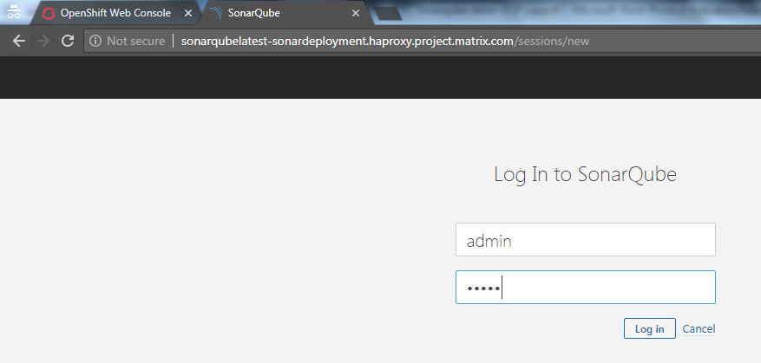

Navigate to “Administration🡪Marketplace”

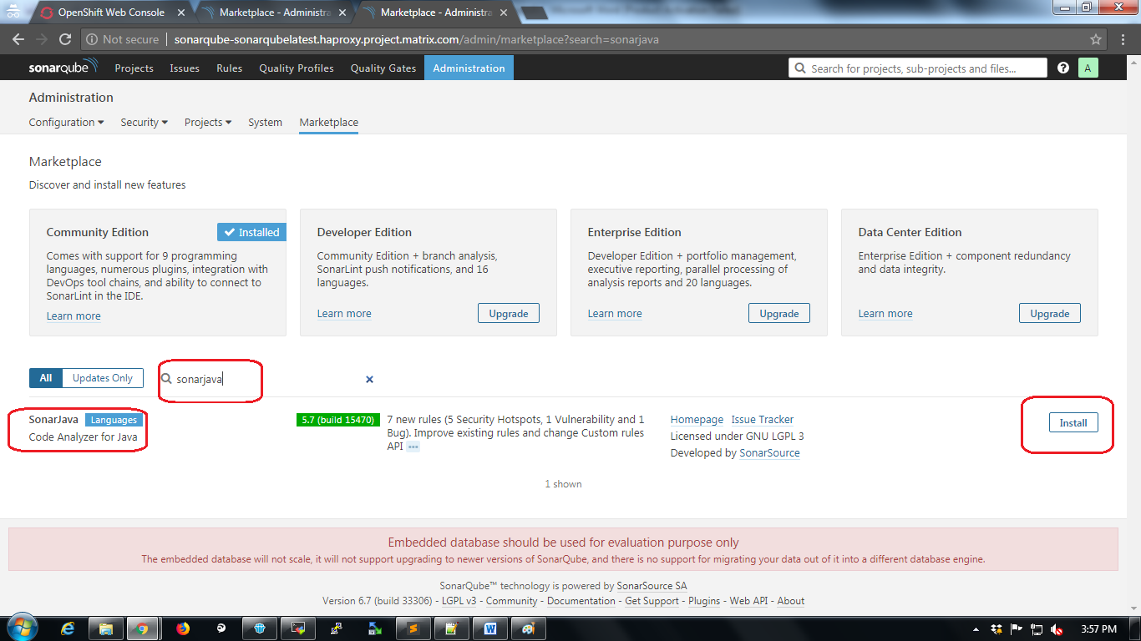

Type “sonarjava” in search bar and click on “Install” button.

After installing the plugin Sonarqube will ask for restart. Restart SonarQube

1. Usage of OCP CLI Commands

|  |  |
| --- | --- |
| Login/User management | |
| **oc login** | authenticate to an openshift cluster |
| **oc logout** | end the current session |
| **oc whoami** | show the current user context |

|  |  |
| --- | --- |
| Project management |  |
| **oc project** | show the current project context |
| **oc get projects** | show all project current login has access to |
| **oc status** | show overview of current project resources |
| **oc new-project** | create a new project in Openshift and change to that context |

|  |  |
| --- | --- |
| Resource management |  |
| **oc new-app** | create a new application from from source code, container image, or OpenShift template |
| **oc new-build** | create a new build configuration from source code |
| **oc label** | add/update/remove labels from an Openshift resource |
| **oc annotate** | add/update/remove annotations from an Openshift resource |
| **oc create** | create a new resource from filename or stdin |
| **oc get** | retrieve a resource (use -o for additional output options) |
| **oc replace** | replace an existing resource from filename or stdin |
| **oc delete** | delete a resource |
| **oc edit** | modify a resource from text editor |
| **oc describe** | retrieve a resource with details |

|  |  |
| --- | --- |
| Cluster management |  |
| **oc adm** | administrative functions for an openshift cluster |
| **oc adm router|registry** | install a router or registry |
| **oc adm policy** | manage role/scc to user/group bindings, as well as additional policy administration |
| **oc adm diagnostics** | run tests/validation against a cluster |
| **oc adm cordon/uncordon/drain** | unschedule/schedule/drain a node |
| **oc adm groups** | manage groups |
| **oc adm top** | show usage statistics of resources |

|  |  |
| --- | --- |
| Additional resource management | |
| **oc patch** | Update fields for a resource with JSON or YAML segments |
| **oc extract** | get configmaps or secrets and save to disk |
| **oc set** | Modify miscellaneous application resources |
| **oc set probe** | Add a readiness/liveness probe on pod template/deployment configuration |
| **oc set volumes** | Manage volume types on a pod template/deployment configuration |
| **oc set build-hook** | Set a script/command to execute as part of the build process |
| **oc set build-secret** | set a secret to be included as part of the build process |
| **oc set env** | set environment variables on a pod template/deployment configuration/build configuration |
| **oc set image** | update the image for deployment configurations/ daemonsets |
| **oc set triggers** | set triggers for deployment configurations/build configurations |

|  |  |
| --- | --- |
| Operational commands |  |
| **oc logs** | retrieve the logs for a resource (build configurations, deployment configurations, and pods) |
| **oc rsh** | remote shell into a container |
| **oc rsync** | copy files to or from a container |
| **oc exec** | execute a command in a container |
| **oc run** | create a deployment configuration from image |
| **oc idle** | scale resources to zero replicas |

|  |  |
| --- | --- |
| Build / Deploy |  |
| **oc rollout** | manage deployments from deployment configuration |
| **oc rollout latest** | start a new deployment with the latest state |
| **oc rollout undo** | perform a rollback operation |
| **oc rollout history** | oc rollout history - View historical information for a deployment configuration |
| **oc rollout status** | watch the status of a rollout until complete |
| **oc tag** | tag existing images into image streams |
| **oc start-build** | start a new build from a build configuration |
| **oc cancel-build** | cancel a build in progress |
| **oc import-image** | pull in images and tags from an external Docker registry |
| **oc scale** | change the number of pod replicas for a deployment |

### Examples

#### Login

First, we can login to the cluster to interact with Openshift via CLI

$ oc login -u myuser https://openshift.example.com Authentication required for https://openshift.example.com Username: myuser

Password:

Note that leaving the -p option off of login prompts for password. Additionally we can verify our user context:

$ oc whoami myuser

Create Project

Let's list out our current available projects (those that we have at least view access for):

$ oc get projects

If this is our first login and no one has added us to any existing projects, there shouldn't be any projects listed. Let's create a project (allowed by self-provisioner role to all authenticated users, in the default Openshift policy installation).

$ oc new-project myproject --display-name='My Project' --description='cool project owned by myuser'

Now using project "myproject" on server "https://openshift.example.com:443".

To build a new example applicatin on Ruby you can add applications to this project with the 'new-app' command. For example, try:

oc new-app centos/ruby-22-centos7~https://github.com/openshift/ruby-ex.git

If you want to view the specifics of the project definition, output the full spec to YA

$ oc get project myproject1 -o yaml apiVersion: v1

kind: Project metadata:

annotations:

openshift.io/description: A really cool project owned by myuser openshift.io/display-name: My Project

openshift.io/requester: myuser openshift.io/sa.scc.mcs: s0:c51,c20

openshift.io/sa.scc.supplemental-groups: 1000000000/10000 openshift.io/sa.scc.uid-range: 1000000000/10000 creationTimestamp: 2017-02-10T15:36:18Z

labels:

name: myproject resourceVersion: "32381158"

selfLink: /oapi/v1/projects/myproject uid: aa94c906-efa6-11e6-af71-02a55ffb157d

spec: finalizers:

* openshift.io/origin
* kubernetes status:

phase: Active

Add users to project

We can add additional users to our project by default, since self-provisioners get the "admin" role for any project they create:

$ oc adm policy add-role-to-user edit anotheruser

This allows anotheruser to edit resources within the project, but not manage policy

Create app from code and image

$ oc new-app centos/ruby-22-centos7~https://github.com/openshift/ruby-ex.git

--> Found Docker image 06f0cdc (2 days old) from Docker Hub for "centos/ruby-22- centos7"

Ruby 2.2

--------

Platform for building and running Ruby 2.2 applicationsTags: builder, ruby, ruby22

* An image stream will be created as "ruby-22-centos7:latest" that will track the source image
* A source build using source code from https://github.com/openshift/ruby-ex.git will be created
* The resulting image will be pushed to image stream "ruby-ex:latest"
* Every time "ruby-22-centos7:latest" changes a new build will be triggered
* This image will be deployed in deployment config "ruby-ex"
* Port 8080/tcp will be load balanced by service "ruby-ex"
* Other containers can access this service through the hostname "ruby-ex"

--> Creating resources with label app=ruby-ex ... imagestream "ruby-22-centos7" created

imagestream "ruby-ex" created buildconfig "ruby-ex" created deploymentconfig "ruby-ex" created service "ruby-ex" created

--> Success

Build scheduled, use 'oc logs -f bc/ruby-ex' to track its progress. Run 'oc status' to view your app.

The new-app command handles the majority of resource creation via template. Notice that deploymentconfig/buildconfig/service/imagestream were all set up.

Get resources

We can view the resources that were created as part of the new-app command, as well as the build/deploy resources that were created automatically. Notice that the new-app automatically started a new build of our code, and the deployment config watches successful builds to know when to next rollout/deploy. A good place to start with viewing application status is checking the pods in your project:

$ oc get pods

NAME READY STATUS RESTARTS AGE

ruby-ex-1-a7y56 1/1 Running 0 24m ruby-ex-1-build 0/1 Completed 0 26m

This shows us the build pod completed successfully. Additionally we can see that there is one ready and running pod deployed with our application.

The status command shows us similar results:

$ oc status -v

In project My Project (myproject1) on server https://openshift.example.com:443 svc/ruby-ex - 172.30.36.21:8080

dc/ruby-ex deploys istag/ruby-ex:latest <-

bc/ruby-ex source builds https://github.com/openshift/ruby-ex.git on istag/ruby- 22-centos7:latest

deployment #1 deployed 26 minutes ago - 1 pod Warnings:

* dc/ruby-ex has no readiness probe to verify pods are ready to accept traffic or ensure deployment is successful.

try: oc set probe dc/ruby-ex --readiness ...

View details with 'oc describe <resource>/<name>' or list everything with 'oc get all'.

Add a volume

If we want to attach a volume to our pods, the oc set volume command can be used:

$ oc set volume dc/ruby-ex --add --mount-path=/mnt/emptydir info: Generated volume name: volume-7d1e8 deploymentconfigs/ruby-ex

$ oc get pods

NAME READY STATUS RESTARTS AGE

ruby-ex-1-a7y56 1/1 Running 0 2h ruby-ex-1-build 0/1 Completed 0 2h

ruby-ex-2-deploy 0/1 ContainerCreating 0 5s

In this example, a simple emptyDir volume was attached, though the same command can be used for Persistent Volumes. Also notice that the deployment configuration has a ConfigChange trigger, so adding this volume automatically started a new deployment.

Edit resource

Making a change to any Openshift resource is simple. Let's change the /mnt/emptydir mountpath above to /mnt/appdata:

$ oc edit dc ruby-ex

# Please edit the object below. Lines beginning with a '#' will be ignored,

# and an empty file will abort the edit. If an error occurs while saving this file will be

# reopened with the relevant failures. #

...

volumeMounts:

- mountPath: /mnt/emptydir /mnt/appdata name: volume-7d1e8

...

Saving the file in your text editor will update the resource, or report errors if validation did not succeed. Note that this change on the deployment config kicks off another deployment for our app.

Start build

If a new build from source is desired:

$ oc start-build ruby-ex build "ruby-ex-2" started

Watch build

The build logs can be watched with the oc logs command (including -f option for follow):

$ oc logs -f bc/ruby-ex

Cloning "https://github.com/openshift/ruby-ex.git" ...

Commit: 855ab2de53ff897a19e1055f7554c64d19e02c50 (Merge pull request #6 from aj07/ typo)

Author: Ionut Palade [<PI-Victor@users.noreply.github.com>](mailto:PI-Victor@users.noreply.github.com) Date: Mon Dec 12 14:37:32 2016 +0100

---> Installing application source ...

---> Building your Ruby application from source ...

---> Running 'bundle install --deployment --without development:test' ... Fetching gem metadata from https://rubygems.org/...............

Installing puma 3.4.0

Installing rack 1.6.4

Using bundler 1.7.8

Your bundle is complete!

Gems in the groups development and test were not installed. It was installed into ./bundle

---> Cleaning up unused ruby gems ...

Pushing image 172.30.114.236:5000/myproject/ruby-ex:latest ... Pushed 7/9 layers, 78% complete

Pushed 8/9 layers, 89% complete Pushed 9/9 layers, 100% complete Push successful

Start Deploy

Most configuration or image changes will automatically start a new deploy by default, but new deployments can be started manually as well:

$ oc rollout latest ruby-ex deploymentconfig "ruby-ex" rolled out

Watch Deploy

The overall deployment status can be watched via oc logs command:

$ oc logs -f dc/ruby-ex

--> Scaling up ruby-ex-5 from 0 to 1, scaling down ruby-ex-4 from 1 to 0 (keep 1 pods available, don't exceed 2 pods)

Scaling ruby-ex-5 up to 1 Scaling ruby-ex-4 down to 0

--> Success

Additionally container logs can be viewed with oc logs:

$ oc logs ruby-ex-5-kgzvd

[1] Puma starting in cluster mode...

[1] * Version 3.4.0 (ruby 2.2.2-p95), codename: Owl Bowl Brawl

[1] * Min threads: 0, max threads: 16

[1] * Environment: production

[1] * Process workers: 8

[1] * Phased restart available

[1] * Listening on tcp://0.0.0.0:8080

[1] Use Ctrl-C to stop

[1] - Worker 2 (pid: 29) booted, phase: 0

[1] - Worker 1 (pid: 25) booted, phase: 0

[1] - Worker 5 (pid: 41) booted, phase: 0

[1] - Worker 3 (pid: 33) booted, phase: 0

[1] - Worker 0 (pid: 21) booted, phase: 0

[1] - Worker 4 (pid: 37) booted, phase: 0

[1] - Worker 6 (pid: 45) booted, phase: 0

[1] - Worker 7 (pid: 60) booted, phase: 0

Remote shell

Interacting directly with the container is simple with oc rsh:

$ oc rsh ruby-ex-5-kgzvd sh-4.2$ ls

Gemfile Gemfile.lock README.md bundle config.ru

Create route

$ oc expose service ruby-ex route "ruby-ex" exposed

With no other options defined this will create a route for your application using the default route naming (ex: $appname-$projectname.openshift.example.com)

Idle app

We're done testing our application, so we can idle the service in order to save resources. This interacts with a Kubernetes service to set the pod replicas to 0, and when the service is next accessed will automatically boot up the pods again:

$ oc idle ruby-ex

Marked service myproject1/ruby-ex to unidle resource DeploymentConfig myproject1/ ruby-ex (unidle to 1 replicas)

Idled DeploymentConfig myproject1/ruby-ex

Delete app

If we're completely done with our application, we can delete resources within the project (or the project itself) to clean up:

$ oc delete services -l app=ruby-ex service "ruby-ex" deleted

$ oc delete all -l app=ruby-ex buildconfig "ruby-ex" deleted imagestream "ruby-22-centos7" deleted imagestream "ruby-ex" deleted deploymentconfig "ruby-ex" deleted

$ oc delete project myproject project "myproject" deleted

**Additional Operations (not included in upstream guide)**

Sometimes with automation there's a desire to control YAML resources in SCM, and ensure those resources match the current state as defined in code. However, we may not know if a resource requires an add or update operation via the Openshift CLI. The following can be used to idempotently add/update most resources regardless of their current state:

$ oc create -f myresource.yaml || oc replace -f myresource.yaml

Gather information on a project's pod deployment with node information

$ oc get pods -o wide

Note: Often can be used with 'watch' command to monitor in real-time the status of pods for a project.

See interesting actions within a project:

oc get events --sort-by='{.lastTimestamp}'

or in reverse order:

oc get events --sort-by='{.lastTimestamp}' | tac